
TECHNOLOGIES LTD.
PVX PLUS

Programming
in
PxPlus

Notice
This document and PxPlus may be used only in accordance with the accompanying License Agreement. You may not use, copy, modify, or transfer PVX Plus software or this documentation except as expressly provided in the license agreement.
Information in this document is intended solely as general information with respect to common business issues and is not to be construed as professional advice. It is always best to consult a tax or accounting professional for all tax and account related questions. THE INFORMATION HEREIN IS PROVIDED "AS IS" AND ALL WARRANTIES ARE EXPRESSLY DISCLAIMED, INCLUDING BUT NOT LIMITED TO ANY WARRANTY: OF MERCHANTABILITY; OF FITNESS FOR ANY PARTICULAR PURPOSE; OF NON-INFRINGEMENT OF ANY PROPRIETARY RIGHT OF ANY THIRD PARTY IN ANY COUNTRY; OTHERWISE ARISING OUT OF ANY PRODUCT, PROPOSAL, SPECIFICATION OR SAMPLE; AND ANY WARRANTY THAT THE DOCUMENT IS ERROR FREE. No license, express, implied, by estoppel or otherwise, to any intellectual property right is granted by this document. PVX Plus Technologies may make changes to the information in this document at any time, without notice. Recipient is solely responsible for assessing the suitability of the information and assumes all risk of use.
© 2024 PVX Plus Technologies Ltd. All rights reserved. PVX Plus, PVX Plus logos, and the PVX Plus product and service names mentioned herein are registered trademarks or trademarks of PVX Plus Technologies Ltd., or its affiliated entities. All other trademarks or registered trademarks are the property of their respective owners.

Contents
1. Getting Started 4
Introduction 4
The Basics 5
Command Formats 25
Variables and Expressions 27
Program Flow 40
Terminal and Printer Input/Output 54
File Handling 65
Debugging Techniques 93
Error Processing 103
2. Advanced Programming 107
Introduction 107
User-Defined Functions 108
Subprograms 113
Advanced File Access 116
PREFIX Directive 131
Function and Control Keys 134
Mouse Handling 138
Tailoring the Environment 140
3. Reference 147
Graphical Controls 147
Data Dictionary 154
Unique to PxPlus 155
Link and Device Files 180

1. Getting Started

Introduction
PxPlus is an exceptionally powerful, versatile and intuitive programming language for building sophisticated business applications - applications that are ready to accommodate future technologies and a variety of host platforms. The language is a derivative of ProvideX, which itself was a dialect of Business Basic. PxPlus is designed to be easy to learn and to use.

This section introduces the features of the PxPlus language and development environment.
Topics in this section:
- Tour of the PxPlus development environment
- Learn to write and edit a simple program
- Overview of terminal and printer input/output
- PxPlus file types and file handling
- Debugging and error handling techniques

The Basics
About PxPlus
PxPlus is designed for use in business applications, as it is oriented towards integer math and values with two decimal points (monetary values). The language includes a file/database handler that provides Keyed file access with up to 16 different keys, file and record locking, and an easy-to-use interface for terminal and printer output.
Along with the processing capabilities of the language, the environment provides facilities for function key control, automatic error detection and correction, and program security. It is completely portable - versions of PxPlus are available for most major operating systems and for most hardware platforms. Programs and data files developed on any platform are completely transportable to any other platform and can be simply copied from one system to another without major modifications.

Terminology
To help you get started with writing simple programs, let's look at the following terms:
Directives | Directives are PxPlus commands that "direct" the system to perform certain tasks.  They are described in the PxPlus Help documentation (under the Language Reference section), complete with mandatory and optional syntax elements.
Mnemonics | Mnemonics are used to control output to both terminals and printers.  Mnemonic instructions are enclosed in single quotation marks; e.g. 'CS'.
System Variables | System Variables provide system information, such as the date and time.  You can use system variables wherever normal program variables would be used; however, you cannot modify them in your program.
System Functions | System Functions are included in PxPlus and can be used in any expression.  A function consists of a three-character function name followed by (in parentheses) the parameters for the function and an optional error transfer. The number and type of parameters vary from function to function.
System Parameters | System Parameters are enclosed in single quotation marks like mnemonics; e.g. 'LC'.  These parameters are normally for use at startup to define your system's operation under PxPlus.
These terms will be covered in more detail as you go through this training manual.
Additional information can be found under the Language Reference section of the PxPlus Help documentation.

Training Setup
Create a directory called "C:\pxplustrain". Make this the Start in directory for a PxPlus desktop shortcut.
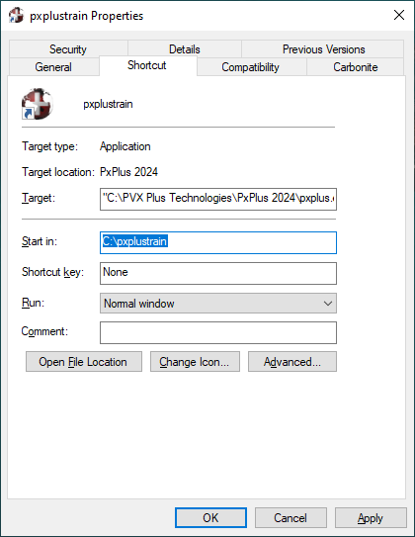
In Windows, click the PxPlus shortcut to invoke a PxPlus session. This will start the PxPlus session within a new console window.

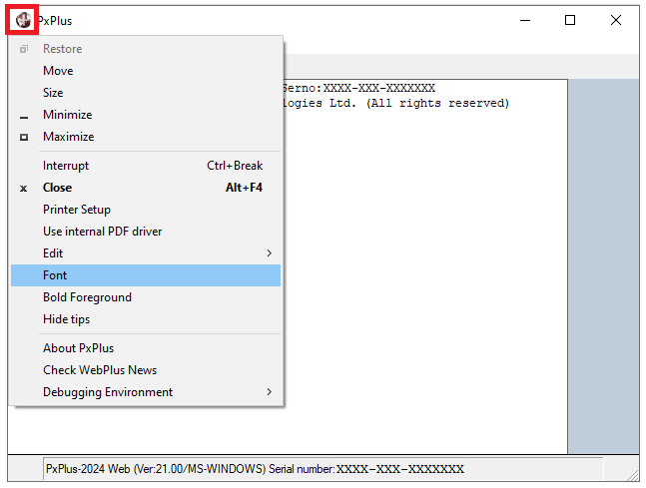
Changing the Font size changes the size of the work area, the white area within the Command window.
Click the PxPlus icon to access a drop-down menu.
Click the PxPlus icon in the top left corner to access a drop-down menu that enables you to manipulate console properties and session-related actions.
Minimize the PxPlus window and then close and restart PxPlus. Your next PxPlus session will start minimized, and any change you made to the Font face and size will have been saved.

These settings are saved in the pxplus.ini file each time PxPlus is terminated. Depending on which version of PxPlus and Windows you are using, the pxplus.ini file will be created in the Windows directory or the PxPlus directory.
Only non-default settings are saved by PxPlus in the pxplus.ini file. The pxplus.ini file on your system is probably somewhat different from the one shown below.
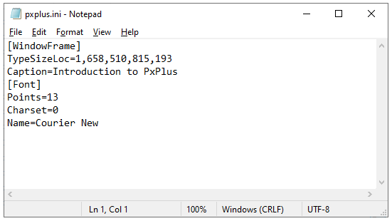
You may add a Caption= line to the [WindowFrame] section and save.
The next time you start PxPlus, your caption should appear on the Command window.
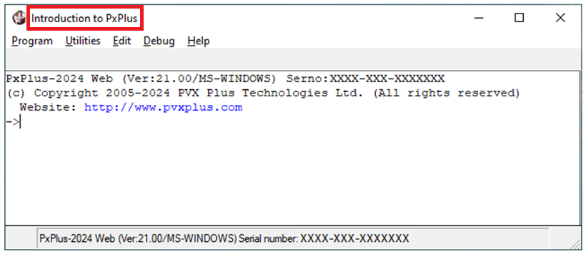
You may comment out a line in the file by prefixing a ; (semi-colon) to the beginning of the entry.

You can maintain multiple .ini files on your system and specify a different (customized) version for each application - not named pxplus.ini.
In the following example, PxPlus would search for "myapp.ini" in the application directory, which, in this case, is C:\pxplustrain.
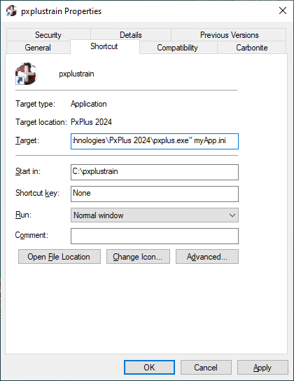
For more information, refer to the Tailoring the Environment section of this training manual, as well as the Introduction to Using PxPlus Help documentation.

PxPlus for Windows is normally installed to its own directory, which is named according to the PxPlus version being installed; e.g. C:\PVX Plus Technologies\PxPlus 2024.
For some of the exercises in this training manual, we will look at the utility programs that install to the Lib (library) subdirectory.
Files in the Lib subdirectory are prefixed with the _ (underscore) character. When referring to any of these programs from within PxPlus, a leading underscore is replaced with an * (asterisk).
To load the utility program "_", the following command would be used: LOAD "**".
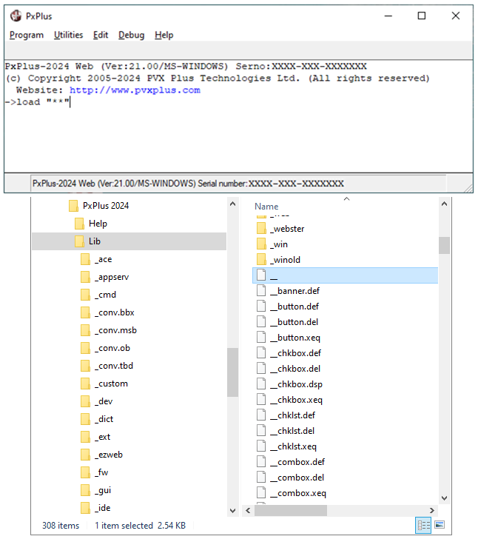
We will look at the built-in utilities and other programs in the Lib subdirectory. Since these programs are written in PxPlus, you will be able to view the code by using the LIST command.
Standard installations of PxPlus include a compiler and program de-compiler (Lister), as well as run-time service modules. Because PxPlus is an interpreted language, programs written in PxPlus can only be run on a system where PxPlus has been installed.
The compiler portion takes source statements and compiles them to an object code. During the compile process, syntax is verified. The object code produced by the compiler is used in the execution of an application. This object code is maintained in memory and can be reconverted to readable code by the Lister.
Command Mode
PxPlus has two programming environments - Command mode and Execution mode. By default, PxPlus initializes in Command mode and displays the -> prompt.
Directives and statements can be entered or edited in Command mode. Statements that do not start with a line number are executed immediately. Statements that begin with a line number will not be executed until a RUN command is entered. Any syntax errors are reported immediately as input is terminated.
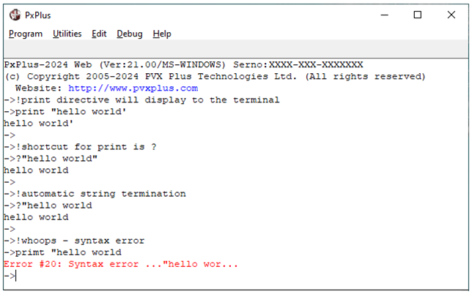
Where closing quotes are omitted, PxPlus automatically appends them.

This table lists some of the keyboard shortcuts:
Keyboard Shortcut |  | Function
? | (question mark) | PRINT
/ or \ | (forward or back slash) | LIST
` | (back apostrophe) | EDIT
. | (period) | Step through program
! | (exclamation mark) | Comment
'' | (double quote) | Shell to operating system
Full Input Editing
In Command mode, most edit keys function as you would normally expect. For example, the Backspace key deletes the preceding character; the Left/Right arrows move through the input.
In addition, the following keyboard actions are available:
Ctrl+Backspace  or  Delete | Erases and clears input and resets input field to spaces.
Ctrl+End | Clears input from cursor to end of line.
Tab  Shift+Tab | Advances/backspaces 10 spaces over input.
Ctrl+Right Arrow | Advances to the next word.
Ctrl+Left Arrow | Goes to the previous word.
Command Line History/Recall
A history of lines entered is kept in an internal buffer and is accessible while in console mode using Up and Down arrow keys. Each line may be edited when recalled and/or reused by pressing Enter.
The number of lines kept in the buffer is configurable with the 'SL' system parameter - default size is 32 lines. The value of the 'SL' parameter may range from 4 to 100 lines.

Execution Mode
Statements with a leading line number are used to construct programs and will not execute until a RUN or CALL directive is issued, at which point Execution mode begins. The prompt changes from -> to -: to indicate that the program has been changed but not saved.
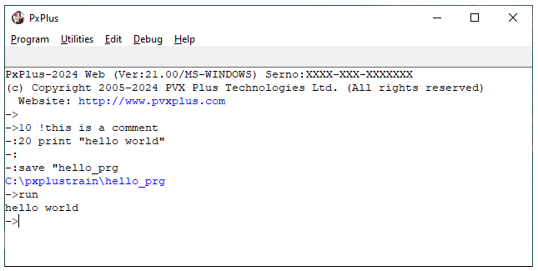
PxPlus will remain in Execution mode until:
- Program completes via an END, QUIT, RELEASE or BYE directive
- An error occurs
If execution is interrupted, the system returns to Command mode and displays the next statement to be executed. The prompt displays a number indicating how many levels of programs are currently being used (each subprogram CALL uses a different level).
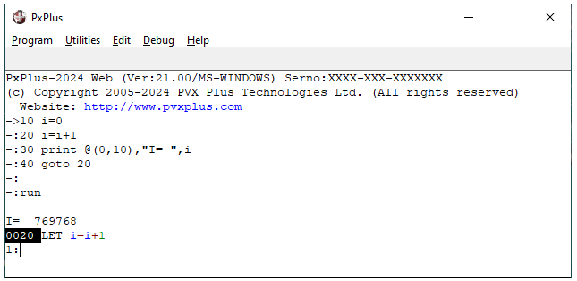
Program was performing at line 0020 when BREAK key was pressed.
Program was executing at level 1.
To resume execution, enter the RUN command.
To terminate the current program, enter the END command.
Note:
Programs do not have to be SAVED to be RUN. You may SAVE a program with any name and/or file extension you prefer; however, the extension .pvx is not recommended.

Directives
All processing in PxPlus is controlled by directives - keywords that "direct" the system to perform certain tasks.
This table lists some commonly used directives:
BEGIN | Reinitialize current session; close files; clear all non-global variables; release memory to the system. See CLEAR and RESET directives.
START | Reset files and variables, including global files and global variables.
Button
BYE | Terminate session; close all opened files; return memory to the operating system and terminate PxPlus. See QUIT and RELEASE directives.
DIM
PRINT | Display information to a terminal, a printer or a file if file number specified.
LET | Assign value to a variable.
DUMP | Print all variables in use by program, including the system variable ERR, as well as current program name, line number, FOR..NEXT, GOSUB/RETURN stack.
LOAD | Read a program into memory for execution, listing or modification. LAOD is also acceptable.
LIST | Converts program statements to readable format and outputs to terminal or file. LSIT is also acceptable.
DELETE | Remove lines from program, or if no lines are specified, unloads program.
RUN | Start or continue execution of a program.
END | End program.
EDIT | Change an existing statement.
SAVE | Copy current program to file specified.
INPUT | Issues a prompt to terminal and processes response.
CWDIR | Change working directory.
GOTO | Transfer control to line referenced.
MSGBOX | Causes a window to be presented in the middle of the screen in which a message is presented.

Exercises
Use the PRINT directive and the ? shortcut to display a string literal on the terminal. The second example shows output positioning with the @ operator:
PRINT "HELLO WORLD
? @(10,10),"HELLO WORLD
Use the LET directive to assign values to a string variable and a global string variable:
LET X$="HELLO
LET %X$= "JELLO
Use the DUMP directive to output program and variable information. Then, use the BEGIN directive to reinitialize the session. Use the START directive, and then DUMP again.
Use the LOAD and the LIST directives to view a program. Options for the LIST directive include listing a range and displaying with indentation:
LOAD "*ufv
LIST
LIST 200,400
LIST EDIT 200,400
Use the DELETE directive to remove lines from a program:
DELETE 200,400
LIST
Use the DELETE directive to remove the program from memory:
DELETE
LIST
Use the RUN directive to run a program:
LOAD "*ufv
RUN
DELETE
Use the RUN directive to load and run a program. Use the END directive to halt execution:
RUN "**
stop execution <ctrl+break>
END
Mnemonics
Mnemonics are special control sequences for output to a display device or printer.

This table lists some commonly used mnemonics:
'CS' | Clear screen.
'CH' | Position cursor at home, i.e. @(0,0).
'BLACK' | Output text in black.  For other available colors, see the list of Mnemonics in the PxPlus Help documentation.
'_RED' | Output text with red background (as above).
'CE' | Clear from cursor to end of screen.
'CL' | Clear from cursor to end of line.
'DF' | Set current attributes as defaults (color, foreground/background, blinking, etc.).
'RM' | Reset to default attributes.
'BR' | Begin reverse video mode. Foreground color becomes background color and vice-versa.
'LF' | Advance one line and return to column 0 (line feed).
'FF' | Advance page (issue form feed).
Note the effects of mnemonics in the following PRINT statements:
? 'CS', @(10,10),"HELLO WORLD
? 'CH'
? 'CH','_RED','CE'
? '_BLUE', 'WHITE','DF','CS',@(10,10),"HELLO WORLD
? 'CH','RM','BR',"HELLO WORLD",'RM'
? 'CH','RM','BR',"HELLO WORLD",'CL', 'RM'
? 'LF','RM','BR',"HELLO WORLD",'RM'

System Variables
System variables are internally defined numeric and string variables for providing system information, such as the date and time.

This table lists some commonly used system variables:
LWD | Current working directory.
TIM | Current system time in hours past midnight. See TMS system variable.
PRM | Current parameter settings for PxPlus.
SSN | System software identifier; version number (1,4); machine class (6,3); serial number (10,7).
WHO | Current User ID. See UID system variable.
QUO | Holds the ASCII quote character (").
DLM | Operating system delimiter.
DAY | Returns current system date in MM/DD/YY format (unless reset with the DAY_FORMAT directive).
PGN | Current program pathname.
HFN | Highest unused local file number. See UNT system variable.
ERR | Value of the last error detected by the system.
SEP | PxPlus record field separator.
CTL | Contains a code indicating how input was terminated.
EOM | Character string that terminated the last terminal input.
MSE | Details of the current state of the mouse.
LFA | Number of the last file accessed.

Important Note:
All system variables have reserved three-character names. To avoid potential conflicts with the reserved list (since PxPlus might include more three-character variables in the reserved list in the future), we strongly recommend that you do not use three-character variable names when defining your own program variables.

Exercises
Use the PRINT directive and System Variables to access current system information:
? LWD
? TIM
? PRM
? SSN
? WHO
Use the QUO variable to include quotes within a string:
PRINT "These are "+QUO+"QUOTES"+QUO
Use the DLM and QUO variables in a pathname:
SAVE "c:"+dlm+quo+pvxtrain+quo+dlm+"test"
Use the DAY variable to get the system date and the DAY_FORMAT directive to change the display:
?DAY
DAY_FORMAT "YYYY/MM/DD"
?DAY
Use HFN to open a file to the highest available channel:
LET MY_FN=HFN
OPEN (MY_FN)"."
Use the ERR variable to retrieve the number of the last error:
10 LET MY_FN=HFN
20 OPEN (MY_FN, ERR=OOPS)"my_file"
30 OOPS: PRINT "YOU MADE BOOBOO NUMBER "+STR(ERR)
Display the default separator (SEP):
PRINT SEP ! This causes PxPlus to execute the separator (carriage return and line feed).
PRINT HTA (SEP) ! The HTA function converts unprintable Hex characters to ASCII.
PRINT "hello "+sep+"world"
Get screen and mouse position information from the MSE variable:
LET CUR_STAT$= MID(MSE,1,1) ! MID string function gives substring
PRINT HTA(CUR_STAT$)
System Functions
System functions are numeric or string operations that process values and yield results within a program statement.
This table lists some commonly used system functions:
ASC(str) | Returns the numeric value of a single character string.
CHR(num) | Returns the character value of a numeric.
NUM(str) | Converts a string to numeric.
STR(num) | Converts a numeric value to ASCII string.
DTE(num) | Converts Julian date to formatted string. If 0 passed to the function, defaults to current date.
JUL(num) | Converts date from year, month day to Julian date. If no value passed to the function, defaults to current date.
NUL(str) | Returns test for null; 1 if true (string is null).
NOT | Inverts string bits. If passed a numeric value, will test for non-zero value, returning 1 or 0.
CHG(str) | Returns a comma-separated list of variables that have changed since last CHG.
PTH(num) | Identifies the absolute pathname for the channel number.
STK(num) | Returns statement number/program name executing at the level specified.
FFN(str) | Checks all open files for a reference to the file name specified and returns the file number or -1 if the file is not open.
FID(num) | Returns a description of characteristics of the file specified. Returns one of five formats depending on the 'FF' system parameter.
FIB(num) | Same as FID but format always PxPlus standard.
FIN(num) | Returns detailed physical aspects of the file specified.

Exercises
PRINT ASC ("A")
PRINT CHR (65)
N=NUM("65");PRINT N + 1
STR$="HELLO "+STR(N); PRINT STR$
? DTE(0)
date$=DTE(0:"%Dl %Ml %D/%Y"); PRINT DATE$
?JUL(day)
DATE$=DTE(JUL(DAY):"%Y/%M/%D"); PRINT DATE$
NUL and NOT system functions:
0010 INPUT "ENTER YOUR NAME: ",N$
0020 IF NUL(N$) THEN PRINT "YOUR NAME IS REQUIRED!"; GOTO 0010
0040 INPUT "ADDRESS: ",A$
0050 IF NOT(NUL(A$)) THEN GOTO DONE ELSE PRINT "ADDRESS PLEASE!";
GOTO 0040
0060 DONE: PRINT "BYE"
Using the CHG system function - Enter the following code and execute the RUN directive:
0010 PRINT CHG("X,Y,A$,B$")
0020 LET X=666
0030 LET A$="HELLO WORLD"
0040 PRINT CHG("X,Y,A$,B$")
Using the PTH function:
0010 LET MY_FN=HFN; OPEN (MY_FN)"."
0020 PRINT PTH (MY_FN)
Using the STK function:
RUN "**
Select U (Utilities), then D (Directories) and then V (View) to bring up the View screen.
Halt execution with CTRL+BREAK, then hit ENTER several times until you see a prompt similar to 4>.
PRINT STK(4)
PRINT STK(3)
PRINT STK(2
PRINT STK(1)
Using the FFN function - Enter and RUN the following:
0010 LET X=FFN(".")! FFN returns channel number if the file is open
0020 IF X=-1 THEN LET X=HFN; OPEN (X)"."! If -1 then file is not open
0030 READ RECORD (X,END=DONE)R$
0040 PRINT R$; GOTO 0030
0050 DONE: PRINT "ALL DONE, BYE-BYE!"
0060 END
Using the FIN function:
0010 ! How to use FIN (5,4) - date last modified; see also *it.fil
7210 GET_FILE_INFO:
7220 LET FILE$="."
7230 OPEN (1)FILE$; LET X$=FIN(1)
7250 LET TIME_STAMP$=X$(5,4),T=DEC($00$+TIME_STAMP$),D=INT(T/86400),
T=T-D*86400
7260 LET SV_BY=PRM('BY'); SET_PARAM 'BY'=1970; LET TIME_STAMP$=" on
"+DTE(D,T/3600:"%Ws, %Ms %D %Yl at %hz:%mz:%sz"); SET_PARAM
'BY'=SV_BY
7270 PRINT FILE$+" last modified : "+TIME_STAMP$
7280 CLOSE (1)
Using the FID function:
0010 ! Get file type using FID(10,1)
0020 OPEN (1)"."
0030 LET X$=FID(1)
0040 LET FIL_TYP$=HTA(X$(10,1));PRINT FIL_TYP$
FIL_TYP$ contains a 2-character Hex string value indicating the file type. The following uses the TBL system function to translate this value:
0050 LET FIL_TYP$= TBL(POS (FIL_TYP$ (2,1) ="01234DF") ,FIL_TYP$, "Indexed",
"Serial", "Keyed","Binary","Program","Directory","Device")
0060 PRINT "This file is a "+FIL_TYP$

System Parameters
System parameters are internally defined options for setting up a system's operation or behavior under PxPlus.
(Added both paragraphs)
This table lists some commonly used system parameters:
'FU'  'FL' | Convert all file/program name references to uppercase or lowercase.
'LC' | LIST variables in lowercase.
'LD' | LIST directives in lowercase.
'LE' | LIST outputs indented program.
'NL' | Suppress LET in program LISTing.
'PC'=xxx | Use program caching on LOAD, maintain the last xxx programs in memory.
'NE' | Errors occurring in subprograms will be reported in the subprogram.
'XT' | PxPlus terminates when program drops to Command mode.
'XI' | EXTRACT directive will only restrict other EXTRACTs or WRITEs.
'FI' | Ignores format mask error.
We will look at system parameters in the Tailoring the Environment section of this training manual.

Command Formats
All processing in PxPlus is controlled by the use of directives - commands that tell the system what task is to be performed. Directives are executed in order, from left to right. Once all directives within a statement are executed, PxPlus proceeds to the next statement.
Statement Format
Programs are made up of statements. The general format for a program statement includes a unique line number, a directive, and any parameters to be processed by the directive. Other options include line labels and comments:
Comments are optional but recommended. Comments begin with an ! (exclamation point) or the REM directive. When used in a compound statement, REM needs to be preceded by a ; (semi-colon).

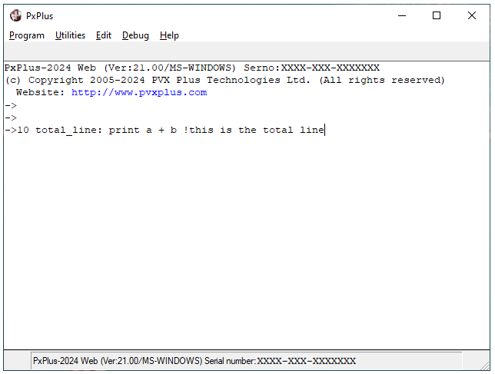
Line labels can be used rather than line numbers to identify a statement within the program. They can be used wherever line numbers are accepted.
Line labels must be an alphanumeric name followed by a : (colon). It is recommended that they also be descriptive.
Line numbers are optional. A line number can be any integer between 1 and 64999. It is suggested that line numbers be assigned in increments of 5 or 10 to allow for easy insertion of additional statements.

If necessary, the program can be renumbered by using the RENUMBER directive

Compound Statements
A statement may contain more than one directive. A ; (semi-colon) must separate each directive and associated parameters.
Any transfer of control within the program will begin processing at the first directive in the compound statement.
In this example, it is impossible to start processing at the PRINT or GOTO directive.

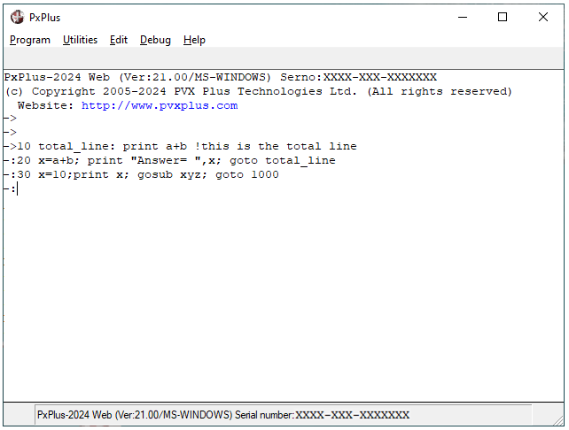
It is possible to transfer control out of and back to a compound statement via directives, which save the current location and then return; e.g. GOSUB/RETURN.
There are some restrictions on compound statements:
- Some directives cannot be included in compound statements, e.g. TABLE, IOLIST.
- A directive that transfers control (e.g. GOTO, RETURN) must be the final directive in a compound statement.
See Directives, Statements and Programs in the PxPlus Help documentation.

Variables and Expressions
PxPlus supports two types of data – numeric and string.
Numeric may be used in various types of numeric manipulation. PxPlus supports numeric literals, variables, expressions and functions, as well as numeric arrays from 1 to 3 dimensions. Numeric output can be formatted with comma, decimal point and dollar sign insertion.
By default, PxPlus maintains precision of 2 (digits to the right of the decimal). During mathematical operations, values are rounded to the current precision. Precision can be reset using the PRECISION directive. The ROUND directive can be used to control rounding of data.
See Numeric Values in the PxPlus Help documentation.
PxPlus includes string manipulation functions, such as concatenation, comparing, scanning and conversion. Character strings typically contain ASCII data but may contain any sequence of 8-bit bytes of data.
See String Values in the PxPlus Help documentation.
Variable Names
Variable names may contain any of the following:
A through Z
0 through 9
_ (underscore)
. (period)
The first character must be alphabetic. It is recommended that you do not use three-character variable names to avoid conflict with PxPlus system variable names.
Note:
Internally, PxPlus considers all variable names to be uppercase so the variable "cat" is the same as "CAT".
Scope
Normal variables are visible to the current program and all subroutines within that program. Scope can be extended or limited by using global or local variables.
Global variables extend the functionality of normal variables. They are common to all subprograms and are not reinitialized by a CLEAR or BEGIN statement.
A global variable can be string, numeric or an array but is identified by a leading % (percent sign) in the variable name. Once a global variable is defined, it remains active and available to all programs and subprograms within a user session until the end of the user session or the execution of a START directive.
Typically, global variables are used for operator codes, dates or company information.
Note:
Global variables are only accessible to the user session that defines them. They are not common between different sessions.
Local variables exist only for the current subroutine, subprogram, FOR..NEXT loop or user-defined function. Local variables must be specifically declared.
If the variable name is currently in use, the system will preserve the current value. Once the stack has been terminated, the system will restore the variables to their original values.
See Variables in the PxPlus Help documentation.
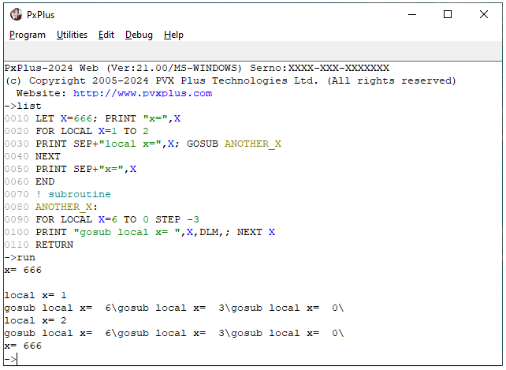
Variable X in the FOR..NEXT loop is maintained separately from X declared in the GOSUB.

Numerics
Literals
Literals may be either simple numerics (which may be signed with optional decimal point) or floating point numbers (using scientific notation). PxPlus maintains up to 14 digits plus a scaling factor (power of 10); therefore, the range of numbers is 10+127 to 10-127.
Variables
By default, the initial value of all numeric variables is 0. Use the LET directive to assign a value to the variable. Optionally, numerics can be named with trailing % (percent sign). These variables can contain only integer values.
Arrays
Arrays can have one, two or three dimensions. Arrays are defined using the DIM directive; unless specified, arrays will be zero-based:
- DIM X[4] yields a one-dimensional array with 5 elements:
X[0] | X[1] | X[2] | X[3] | X[4]
- DIM X[1:4] defines a one-dimensional array with 4 elements:
X[1] | X[2] | X[3] | X[4]
- DIM Y [2,5] defines a two-dimensional array with 18 elements:
Y[0,0] | Y[0,1] | Y[0,2] | Y[0,3] | Y[0,4] | Y[0,5]
Y[1,0] | Y[1,1] | Y[1,2] | Y[1,3] | Y[1,4] | Y[1,5]
Y[2,0] | Y[2,1] | Y[2,2] | Y[2,3] | Y[2,4] | Y[2,5]
- DIM Y [1:2,1:5] defines a two-dimensional array with 10 elements:
Y[1,1] | Y[1,2] | Y[1,3] | Y[1,4] | Y[1,5]
Y[2,1] | Y[2,2] | Y[2,3] | Y[2,4] | Y[2,5]

Access array elements by subscript, preferably within square brackets [ ]; e.g. X [1]. Optionally, round parentheses ( ) may be used for numeric arrays only; e.g. Z (2,2).
Extended Array Functionality
Assigning a value to an entire array: | LET A{ALL} = 10
Assigning a value to a range of array elements: | LET A{1:5}=10
Copying the contents of one array into another: | LET A{ALL} = B{ALL}
Assigning a range of values from one array to another: | LET A{1:5}=B{6:10}
Numeric expressions consist of numeric constants, variables, functions, and/or other numeric expressions, each separated by arithmetic or logical operations.
Order of Precedence (top to bottom)
++ --
^
* /
+ -
= < > <> <= >=
AND
OR
If two operators are of equal precedence, execution is performed from left to right. Round parentheses may be used to change the order of execution:
(A^(B*(A+2)))
The expression will be evaluated from the innermost parentheses outward.

Arithmetic Operators
Operator | Meaning | Example
+ | Addition | A+B
- | Subtraction | A-B
* | Multiplication | A*B
/ | Division | A/B
^ | Raise to | A^B
| | Modulus | A|B
++ | Increment by 1 | A++ or ++A (See below)
-- | Decrement by 1 | A-- or --A

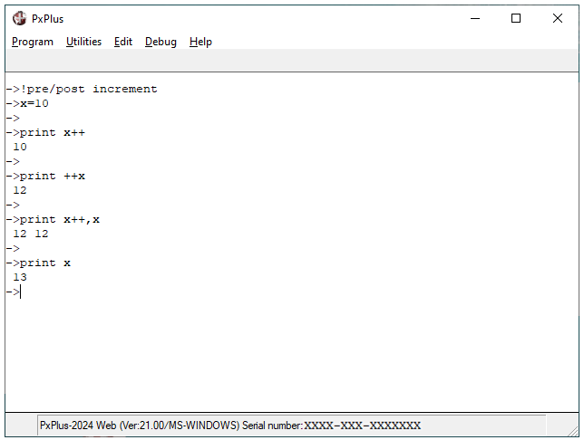
x is incremented after the PRINT directive. If an error occurs on the directive, increment does not take place.
x is incremented before the PRINT directive; however, an error on the directive will prevent the increment.

Logical Operators
Operator | Result
= | Yields 1 if values are equal; else yields 0.
< | Yields 1 if value on left is less; else yields 0.
> | Yields 1 if value on left is greater; else yields 0.
<> or >< | Yields 1 if values are not equal; else yields 0.
<= or =< | Yields 1 if value on left less than or equal; else yields 0.
>= or => | Yields 1 if value on left greater than or equal; else yields 0.
AND | Yields 1 if both values are non-zero; else yields 0.
OR | Yields 1 if either value non-zero; else yields 0.
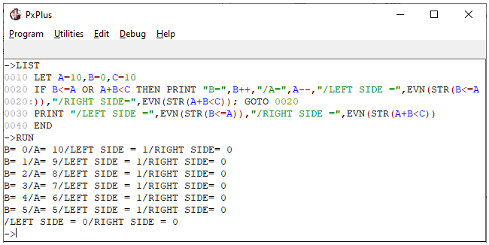
PxPlus attempts to perform a shortcut in evaluation AND and OR relationships:
If the value to the left of OR is non-zero (true), the expression on the right is not evaluated. The relationship evaluates to 1.
If the left side value in an AND relationship evaluates to zero (false), the right side expression is skipped, and the relationship returns 0.
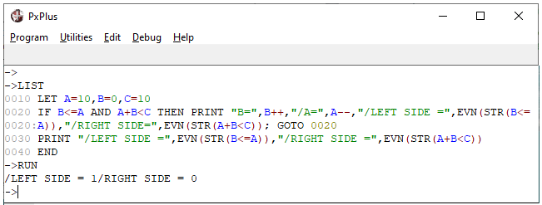
Additional Assignment Operators
Operator | Example | Equivalent to
+= | A+=1 | A=A+(1)
-= | B-=A+1 | B=B-(A+1)
*= | B*=A+1 | B=B*(A+1)
/= | B/=A+1 | B=B/A+1
|= | B|=A+1 | B=B|(A+1)
^= | B^=A | B=B^A

Strings
Literals
A string literal is a series of characters delimited by " (quotation marks). Characters can be letters, numbers, spaces or any displayable character. Spaces included in the literal string are considered integral to the string so " my name " is not equal to "my name".
Quotation marks may be included within a string by use of paired quotation marks, e.g. "my name is ""Joe"" Smith" equals my name is "Joe" Smith.
Hexadecimal String Literals
Hexadecimal strings are delimited by $ (dollar signs) and may contain non-displayable characters. A pair of Hexadecimal digits (0 - 9, A - F) defines each character, each pair representing a single byte of data; e.g. $0D0A$ = carriage return, line feed.
Variables
Naming conventions for string variables are the same as numerics, except that a string variable must be terminated with a $ (dollar sign); e.g. name$.
The maximum length of a string variable is 32,767 characters. All string variables are initialized as null strings (length 0).
String variables may be defined with the DIM directive, allowing definition of the length and contents.
Arrays
String arrays are defined and referenced the same way as numeric arrays.
See String Arrays in the PxPlus Help documentation.

Substrings
A substring is a portion of a string variable. Substrings are accessed by specifying the string variable and (within parentheses) the starting position and, optionally, the desired length of the substring.
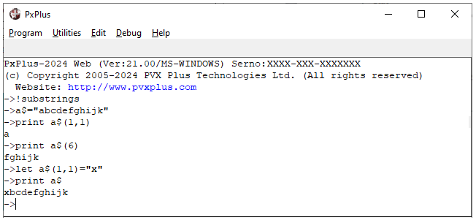
Values can be assigned to a substring using the LET directive.
String Concatenation
Strings and string variables may be joined using the + (plus) operator and the += (plus equals) assignment operator.
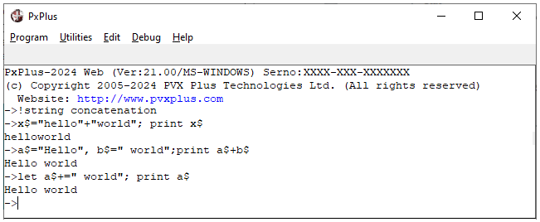

String Comparison
When strings are compared, each character in the string on the left of the operator is compared to the corresponding character in the string on the right. The comparison is of the internal binary value of each byte:
Operator | Example | Result
= | A$ = B$ | Yields 1 if A$ equals B$; else yields 0.
< | A$ < B$ | Yields 1 if A$ less than B$; else yields 0.
> | A$ > B$ | Yields 1 if A$ greater than B$; else yields 0.
<> | A$ <> B$ or A$ >< B$ | Yields 1 if A$ not equal to B$; else yields 0.
<= | A$ <= B$ or A$ =< B$ | Yields 1 if A$ less than or equal to B$; else yields 0.
>= | A$ >= B$ or A$ => B$ | Yields 1 if A$ greater than or equal to B$; else yields 0.
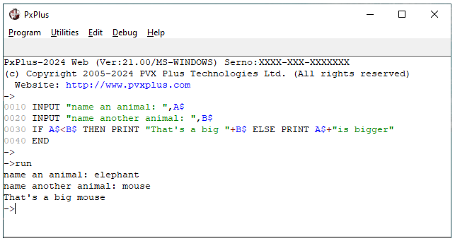
Additional Assignment Operators
Operator | Example | Equivalent to
+= | A$+=B$ | A$=A$+B$
*= | A$*=3 | A$=A$+A$+A$

Simple String Functions
PAD | Pads string to specified length with character, if specified, or spaces (default).  PAD(str, flag, len [,char])  flag:  0 = Left  1 = Right  2 = Pad left and right (centered)  Example: x$=PAD("hello",20,2,"*")
STP | Strips leading/trailing character specified or spaces (default).  STP (str, flag, len[,char])  flag:  0 = Leading  1 = Trailing  2 = Leading and trailing  3 = All  Example: x$=STP(x$,2,"*")
UCS  or  LCS | Converts string to upper/lowercase.  UCS(str) or LCS(str)  Example:  x$=UCS(x$)  x$=LCS(x$)
MID | Returns a substring beginning with offset and to length, if specified; otherwise, to end.  MID(str, offset [,len])  Example: mid$=MID (“hello world”,7,5)
LEN | Returns a numeric value equal to the length of the string.  LEN(str)  Example: L=LEN(x$)
POS | String scan function. Returns a numeric equal to the position within the string where a specified relationship is satisfied or 0 if relationship is not satisfied.  POS (str1 relationship str2 [,increment] [,occurs])  Example:  A$="the quick brown fox"  x=POS("q"=A$)  x=POS("T"=A$)  x=POS("o"=A$,1,2)  x=POS("o",1,0)
  relationship
    = | Position where str1 is found in str2
    > | Position where character in str1 is greater than character in str2
    < | Position where character in str1 is less than character in str2
  increment
    1 | Default, search each character in str2
    -1 | Scan str2 from right to left
  occurs
    1 | Return first occurrence (default)
    0 | Return numeric value of total number of occurrences

Exercises
Given:
X$ = "hello"
MID$=MID("hello world",7,5)
A$="the quick brown fox"
- What is the value in NEW$ if:
NEW$=MID(A$,LEN(MID$))
- What is the value in NEW2$ if:
X=LEN(MID$)
NEW2$=MID(A$,X,X)
- What is the value in STR$ if:
STR$=PAD(X$,6)+MID(NEW$,(POS("i"=A$)),X)+PAD(MID$,6,0)
- Create STR2$ with the value "hello brown fox" by combining string functions.

Program Flow
Transferring control within the program is typically accomplished with the GOTO directive.
The syntax for the GOTO statement is:
GOTO line_ref
Where:
line_ref | Either the line number or line label where execution is to continue.
If a line number is used and no statement exists with the number specified, control is transferred to the statement with the next higher line number:
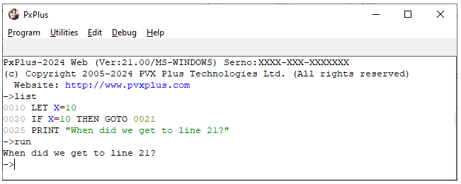

If a line label is specified and no line with the label exists, an error occurs:
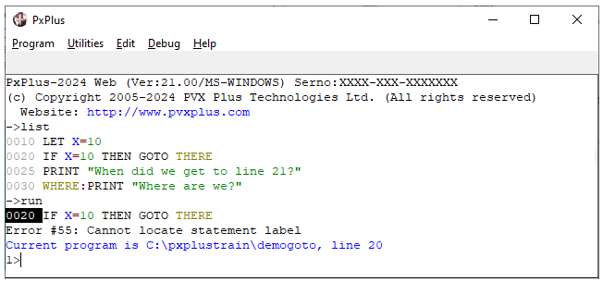

ON ... GOTO/GOSUB Directive
A variation of the GOTO directive is the ON ... GOTO directive, which allows transfer of control based on the value of a numeric variable or expression.
When used in a compound statement, the ON ... GOTO directive must be the final directive.
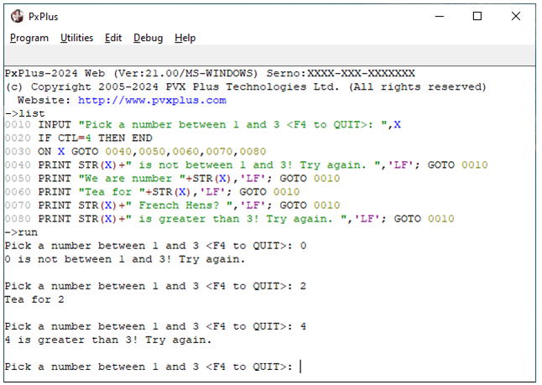
The value of X is evaluated at line 0030. Control passes to given line numbers depending on that value.
If X<=0, control transfers to the first specified statement.
If X=1, control transfers to 0050, etc. Control is passed to the final statement specified (i.e. 0080) if X> the number of entries minus 1 (4 in this case).
It is also acceptable to specify line labels. See the next example.

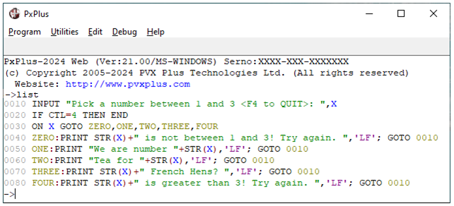

Logical Statement Labels
Logical statement labels can be used to replace line number references in programs. This helps to reduce errors caused by renumbering issues and clarifies the intent of a statement.
Example:
READ (1, KEY=CUST_NUM$,DOM=*NEXT)
Acceptable logical statement labels are:
*NEXT | Next line/statement.
*SAME | Start of current line/statement.
*PROCEED | Continue to next directive.
*BREAK | Emulate a BREAK directive (i.e. continue after loop).
*CONTINUE | Emulate a CONTINUE directive.
*END | Emulate an END directive.
*RETRY | Emulate a RETRY directive (with BSY= option).
*ESCAPE | Emulate an ESCAPE directive.
*RETURN | Emulate a RETURN directive (in subroutine).
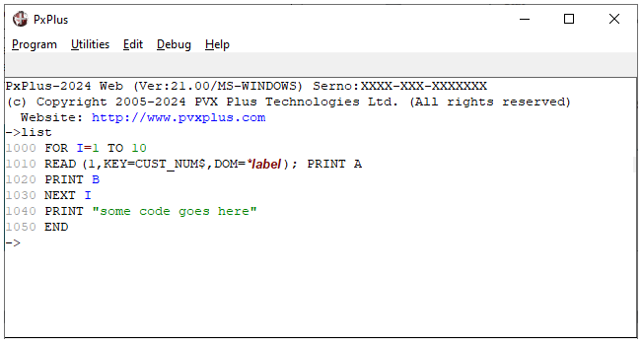
*PROCEED - Goes to PRINT
*END - Goes to the end
*BREAK - Goes to line 1040
*CONTINUE - Goes to line 1030
*NEXT - Goes to line 1020
*SAME - Goes to line 1010
Looping
Three directives within PxPlus allow for controlled looping:
FOR..NEXT
WHILE..WEND
REPEAT..UNTIL
The FOR directive specifies a control variable, a starting value, an end value, and optionally an increment/decrement (called the STEP value with a default value of 1).
A NEXT directive indicates the end of the loop.
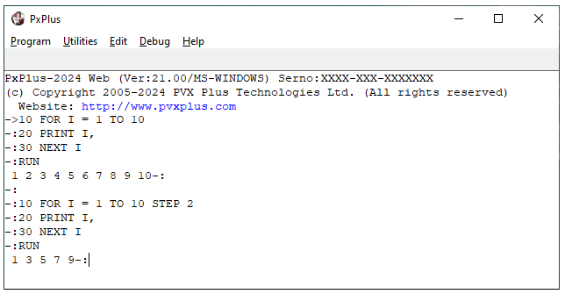
On a FOR directive, the variable specified is set to the starting value. The end value and increment (if present) are saved.
Execution continues until the NEXT directive, at which point the control variable is incremented and then compared to the end value.
If the variable has not gone beyond the end value, control is transferred back to the directive following the FOR; otherwise, execution continues with the directive following the NEXT.

The WHILE directive uses a value to control the loop.
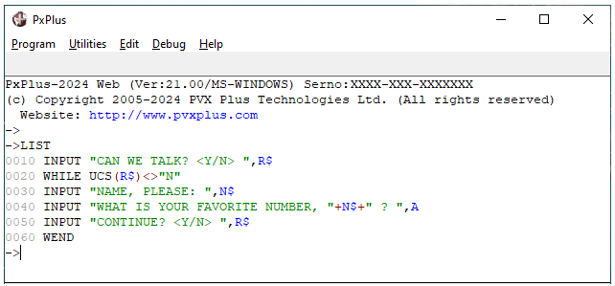
At the WHILE directive, PxPlus tests the condition specified. If true, the location of the directive is saved and execution continues. If false, PxPlus skips forward to the corresponding WEND directive.
At a WEND directive, PxPlus retests the condition. If the value is still true, control loops back to the directive following the WHILE; otherwise, execution continues with the directive following WEND.

The REPEAT directive loops until the condition specified on a subsequent UNTIL directive is satisfied (is true).
When a REPEAT directive is executed, the current location in the program is saved.
When the corresponding UNTIL is encountered, its expression is evaluated. If false, control loops back to the saved location; otherwise, the repeat loop exits and execution continues with the directive following the UNTIL.
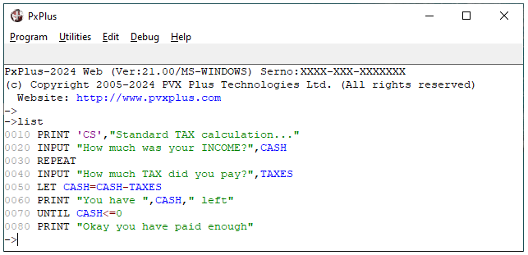
Note:
FOR..NEXT and REPEAT..UNTIL loops will always execute at least once.
In the case of a FOR..NEXT, if the initial value exceeds the final value, the loop is executed once. REPEAT always proceeds into the loop until the UNTIL is reached.
If the initial condition on a WHILE is false, execution skips immediately to the WEND and skips the loop.

CASE/SWITCH Directives
CASE/SWITCH causes control to branch to one of a list of possible statements or CASEs. The value of the expression at the SWITCH statement is compared to the CASE values.
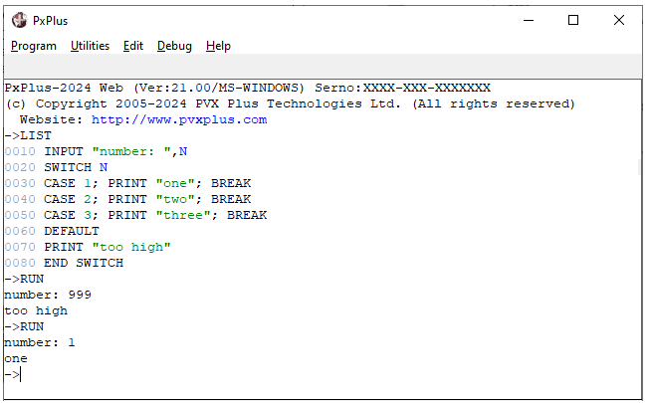
BREAK is required; otherwise, all CASEs will be executed.
If a match is found, execution continues from the matching CASE and continues until a BREAK is encountered or the END SWITCH statement is reached.
If a matching CASE is not found, the DEFAULT branch will be taken, if it exists.

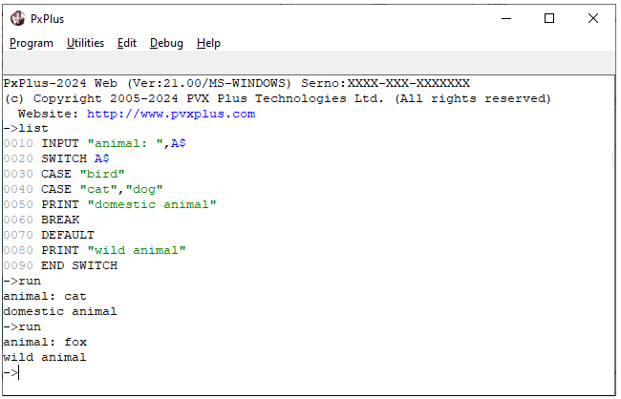
Multiple CASE values can be specified on one CASE.

Subroutines
A subroutine consists of a common series of statements that are executed repeatedly throughout a program. When these statements are needed, the program passes control to the subroutine, which then executes its statements and returns back to the point from where it was invoked. The statements, which comprise the subroutine, are included within the program.
One advantage of subroutines is the elimination of repetitious code, thus reducing overall program size.
Another advantage of subroutines is that by splitting a program into logical sections, they are generally easier to maintain and debug.
The GOSUB directive is used to transfer control to a subroutine. When the GOSUB directive is executed, PxPlus saves the current location on the GOSUB stack and then transfers control to the statement specified (by line or label).
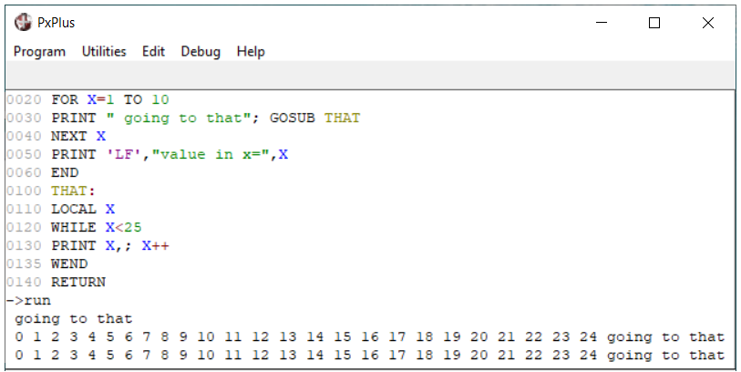
The RETURN directive is used to terminate a subroutine and transfer control back to the location saved on the GOSUB stack.
Alternatively, the EXITTO directive may be used to exit a subroutine. This transfers control to the statement identified on the EXITTO instead of the location saved on the GOSUB stack. There is no limit, assuming available memory, to the number of locations that can be saved on the GOSUB stack.

Note:
The same stack is used for the GOSUB, FOR, WHILE and REPEAT directives; therefore, a RETURN statement can only be executed if all FOR, GOSUB, WHILE and REPEAT directives used within the subroutine have been terminated.
An EXITTO directive can be used to prematurely terminate a FOR..NEXT, WHILE..WEND loop.

SETESC Directive (Break Processing Subroutine)
Normally, when the BREAK key is depressed, PxPlus halts the execution of the current program and drops to Command mode. This can be overridden using the SETESC directive.
SETESC defines the starting line number/label of a subroutine written to handle a BREAK request. It is used to prevent an operator from breaking out of a program.
The syntax of the SETESC directive is:
SETESC stmtref
Where:
stmtref | A line number or statement label to which to transfer control on a BREAK request from the user's terminal during execution.
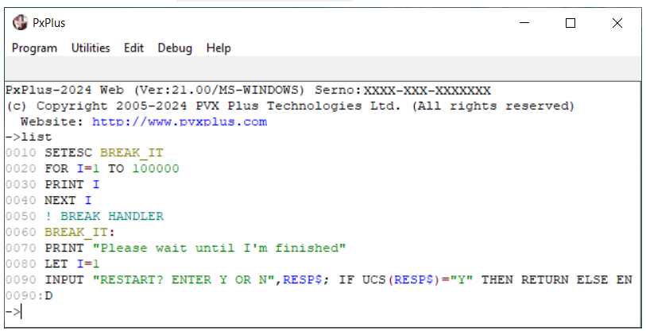
If a SETESC is active and the operator enters a BREAK, the system performs GOSUB to the statement specified on the SETESC directive. This routine can process the BREAK request and, if desired, return to the original program flow by executing a RETURN.
To deactivate the SETESC, set to 0000 (SETESC 0000).

SETESC {ON|OFF} and SETESC {DISABLE|ENABLE} Directives
The SETESC {ON|OFF} directive allows the user to disable ESCAPE/Break key recognition within PxPlus. When the SETESC OFF directive is executed, all user escape requests are ignored. This mode of operation continues for the duration of the session or until a SETESC ON directive is executed.
An ESCAPE/Break will be recognized in those programs that specifically have a SETESC transfer regardless of the ON/OFF status. This allows programs that have escape handling logic to continue to function properly.
The SETESC DISABLE directive causes all subsequent SETESC stmtref to be ignored until a SETESC ENABLE is encountered. The DISABLE option can be used to enable the debugging of a program that has embedded SETESC directives.

Terminal and Printer Input/Output
Displaying on the Terminal
The PRINT directive displays data on the user terminal. It can format and output a list of variables and literals. It also supports the ability to position the output on the terminal screen and allows insertion of terminal control codes through the use of mnemonics.
All data to be sent to a terminal must be in ASCII. String variables and string literals are maintained in ASCII, so they are sent to the terminal as is. Numeric data is maintained in binary format and is converted to ASCII automatically by the PRINT directive.
See Data Format Masks in the PxPlus Help documentation.
Note:
It is important that string variables only contain printable characters. Attempting to print control sequences to a terminal may cause unpredictable results.
By default, a PRINT directive advances one line after outputting data. This can be overridden by terminating the output list with a , (comma).
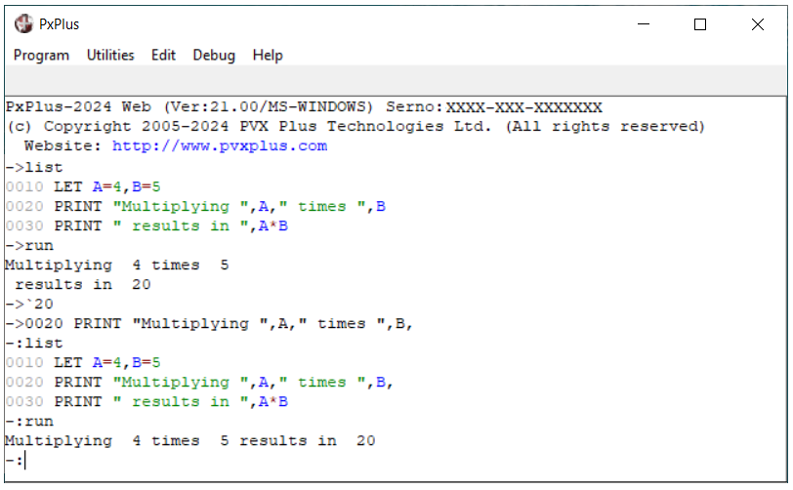

Output Positioning
The @ function can be used to position output, specifying the desired column and, optionally, the line for the output.
The syntax of the @ function is:
@(column-no [, line-no])
Where:
column-no | A numeric value from 0 to the number of columns on the screen (typically 79).
line-no | A numeric value from 0 to the number of lines on the screen minus one (typically 24), indicating the line number to output to.
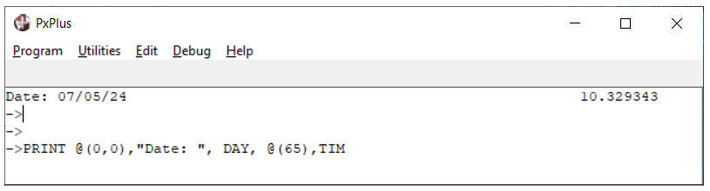
If only the column number is provided, output is positioned at the column specified on the current line.
With a printer (or print file), if the line number is less than the current line, a new page is started.

The PRINT directive can also be used for outputting data to printers or files.
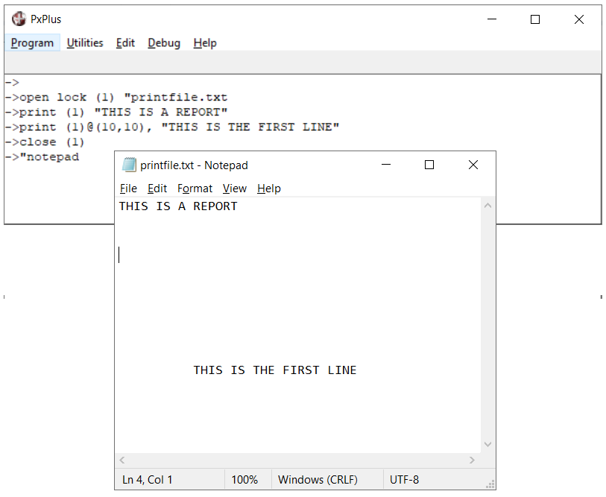

Numeric Format Masks
The conversion of numeric data from literals, variables, or numeric expressions to ASCII can be controlled through format masks. A format mask is a character string that describes how the number is to be converted. One output character is generated for each character in the format mask.
Format masks allow for the generation of fixed format data with the insertion of fill characters to suppress leading/trailing zeroes. See the table on the next page for a list of recognized format mask characters.
A format mask is indicated by a numeric value followed by a : (colon), then the mask:
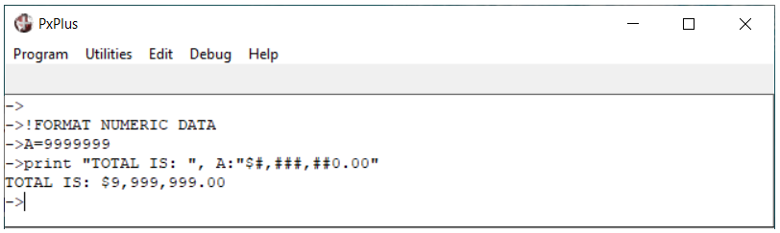
The mask may be defined as a literal string, a string variable, a substring, or a string expression:
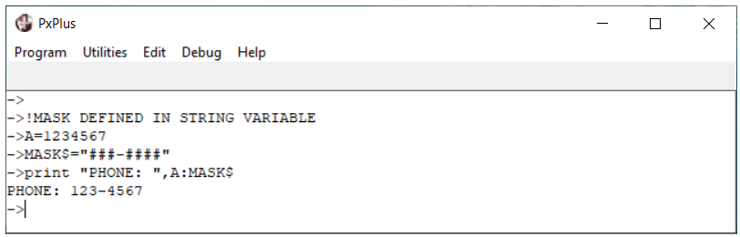
The total number of digits to the left of the decimal point must be sufficient to contain the maximum number to be output; otherwise, an Error #43 (Format mask invalid) is generated. If the 'FI' system parameter is set and a format mask error occurs, the number is output without formatting. Format masks can be used with the STR function; i.e. formatted then used as a string.
This table lists the recognized numeric format mask characters:
Note:
Some numeric format mask characters cannot be used in INPUT and MULTI_LINE directives. See Numeric Format Masks in the PxPlus Help documentation.
Mask | Format Result
0 | Outputs one digit from the numeric value.
# | Outputs one digit of the number.  If digit is zero (0) and no other digits have been output, outputs a fill character; i.e. suppresses leading zeroes.
. | Outputs and aligns decimal point. Only one allowed occurrence per mask.
! | Treated as a '.' but will be replaced with space if the value is zero; i.e. blank when zero.
- | At the front or trailing end of a mask; inserts a '-' (if value <0) or a fill character (if >0).
+ | Outputs a '-' if the number is < 0; otherwise, outputs a '+'. If in front of the number, sign is placed just before the first digit (floating +).
, | Outputs a comma if digits have been output; otherwise, a fill character.
$ | At the front of the number, indicates a dollar sign is to be output in front of the first digit.
* | In front of the number, causes an asterisk to be used as the fill character instead of a space.
~ | Outputs a "~" in lieu of a digit from the input numeric value. This is typically used as a hidden mask character to hide the data from the user.
( OR ) | Outputs parentheses if the value is negative; otherwise, outputs fill character.
CR | Outputs CR if the value is negative; otherwise, it outputs two fill characters.
DR | Outputs CR if the value is negative; otherwise, it outputs DR.
B | Outputs a space.
other | Outputs the specified character.

String Format Masks
String data can be converted through the use of format masks. String Format Masks are typically used to validate that the contents of a string match a predefined format.
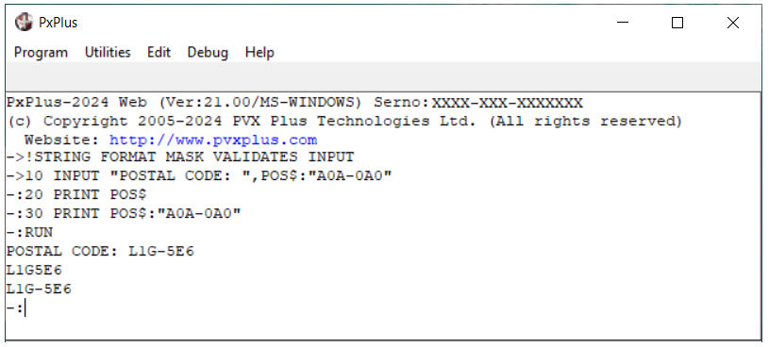
This table lists the recognized string format mask characters:
Mask | Format Result
0 | String must contain a digit (0-9) in this position.
A | String must contain an alphabetic letter (A-Z, a-z) in this position - will convert to uppercase.
a | String must contain an alphabetic letter (A-Z, a-z) in this position.
X | String can contain any character in this position - will convert to uppercase.
x | String can contain any character in this position.
Z | String must contain an alphabetic letter (A-Z, a-z) or a digit (0-9) in this position - will convert to uppercase.
z | String must contain an alphabetic letter (A-Z, a-z) or a digit (0-9) in this position.
~ | Outputs a "~" in lieu of a character from the input string value. This is typically used as a hidden mask character to hide the data from the user as in credit cards.
(n) | A numeric value surrounded by parenthesis may be used to specify a repeat count for the preceding format character; e.g. AAAAA may also be specified as A(5).
other | Outputs the character.
Receiving Terminal Input
The INPUT directive prompts for, receives and validates terminal input.
The syntax of the INPUT directive is:
INPUT list
Where:
list | A list of variables, string literals, mnemonics, expressions or string positions.
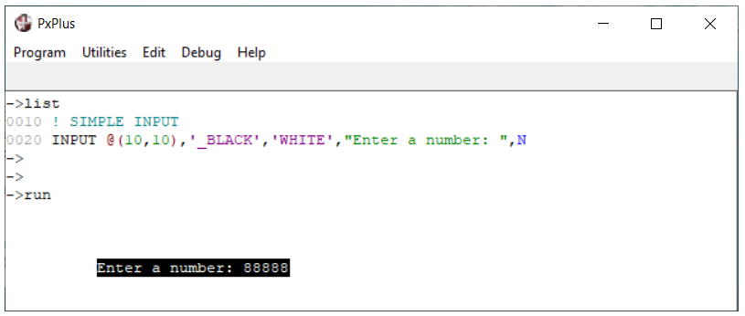
Input accepted from the terminal is passed to the variable.
Non-numeric input in response to the numeric variable causes an error.
All entries in the INPUT directive list, except variables, are displayed on the terminal when the program runs, as will the user response. In cases where it is undesirable to echo the user input, the alternative OBTAIN directive may be used.
The INPUT directive is primarily designed for use with terminals, but it can also be used with other file types.
See File Handling in the PxPlus Help documentation.

Input Edit
It is sometimes desirable to present the user with the current value within a variable and allow them to edit it. The INPUT EDIT directive loads the input buffer with the current contents of the specified variable. The user may then choose to edit the current value or enter a new one:
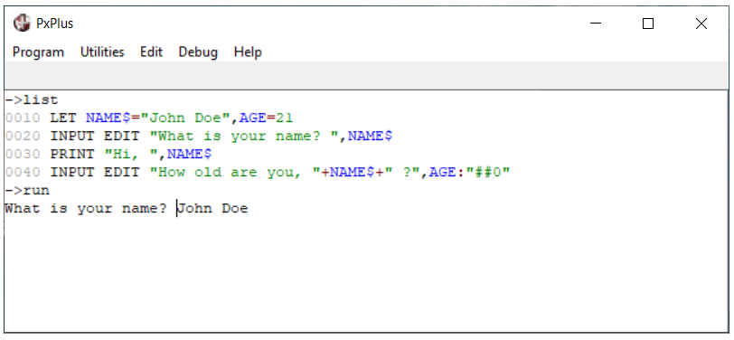
When the program runs, the current value of NAME$ (John Doe) is displayed. If the user begins by hitting a data key, the variable will be reinitialized; otherwise, the user may edit the value with the edit keys and/or <Enter> to accept the default.
Note that line 0040 contains formatted input.
Formatted Inputs
INPUT directives can also contain a format to be used during the Input cycle. This forces the data to adhere to the format mask specified so invalid input is impossible.
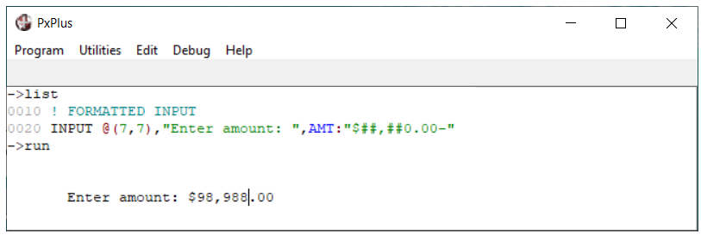
Numeric input format can contain any valid numeric combination of $ # 0 . - ,.
String input format can contain 0 Z A a X x for data. All other characters are fixed insertion data characters.
Input Validation
The INPUT directive provides the ability to validate the input received. Any variable in an INPUT parameter list may be followed by input validation options:
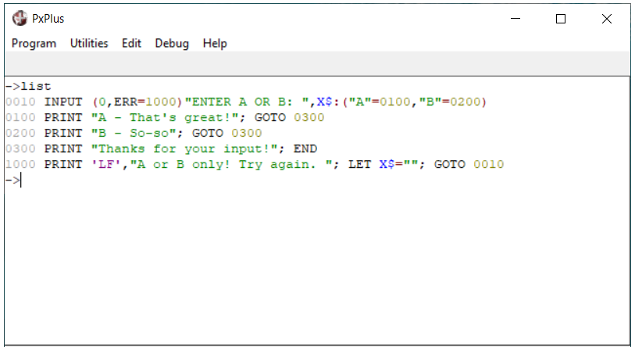
If "A" is input, control transfers to statement 0100.
If the input is "B", control transfers to statement 0200.
Any other values will cause an error and transfer control to statement 1000 through the ERR= option.
See Input Validation in the PxPlus Help documentation.

Input Terminator
To terminate an INPUT directive, the user normally presses the Enter key. This will end input and return the value entered to the program. PxPlus also terminates the input whenever it detects any other Control key or Function key.
To allow the program to determine which key terminated the input, the CTL system variable will be set to a specific value. The program can test this variable to determine what action is to be taken.
The default values for CTL are:
CTL Value | Input Terminator
0 | ENTER or other non-recognized key
1 | Function key 1 (F1)
2 | Function key 2 (F2)
3 | Function key 3 (F3)
4 | Function key 4 (F4)
5 | No terminator; SIZ= limit reached
Note:
Standard conventions on PxPlus programs are:
F4 CTL = 4 should terminate program
F3 CTL = 3 should backup one field
Additional positive CTL values can be defined. Negative CTL values are used by PxPlus internally. These will be discussed later in this training manual.

CTL Subroutine
The SETCTL directive can be used to simplify the processing of CTL values. This directive allows the programmer to establish a subroutine that is to execute whenever the specified CTL value is received by an INPUT statement. When the subroutine RETURNs, the INPUT statement is re-executed.
Example:
0010 SETCTL 4:WRAP_UP
0020 SETCTL 3:BACK_UP
...
0300 BACK_UP:
0310 FLD_NO=FLD_NO-1
0320 EXITTO 0110
...
9000 WRAP_UP:
9010 END
Using the SETCTL directive can simplify the coding of programs that have many INPUT directives and allow for the use of common procedures for CTL processing.

File Handling
PxPlus supports many different types of files and record formats. In most of the cases, all records are the same lengths, each record being composed of one or more data fields. These data fields are maintained on the file with a field separator between each field.
Record 1 | Field 1 | Field 2 | Field 3 | Field 4
Record 2 | Field 1 | Field 2 | Field 3 | Field 4
Record 3 | Field 1 | Field 2 | Field 3 | Field 4
Record 4 | Field 1 | Field 2 | Field 3 | Field 4
Record 5 | Field 1 | Field 2 | Field 3 | Field 4
Record 6 | Field 1 | Field 2 | Field 3 | Field 4
The default field separator character is a Hex 8A.

File Types
PxPlus supports three basic types of files - Serial, Indexed and Keyed:
Serial | A serial (Sequential or Flat ) file that can be accessed one record at a time, from beginning to end.
Indexed | A file in which each record has an index number; file can be accessed by index, as well as sequentially.
Keyed | Most common file type used in PxPlus. Each record has at least one key field and up to 16 alternate keys. This type of file may be accessed by any key field, by index or sequentially.
These will be discussed later in this training manual.

Accessing Files
All file accesses are controlled by the use of file or channel numbers. File numbers may take a value from 0 through 127. File number 0 is reserved for the user terminal, leaving file numbers 1 to 127 available to the user.
File numbers 1 through 63 are treated as local files. Numbers 64 through 127 are global files. All local files are closed upon the execution of a BEGIN or END directive but global files are not. Any file can be closed explicitly by using the CLOSE directive. All files are closed by the START directive or at the end of a user session.
The OPEN directive is used to establish the relationship between a logical file number (channel) and a physical file. In addition, OPENing the file sets a pointer to the beginning of the file and allocates system resources.
All files must be opened before being accessed.
The usual syntax of the OPEN directive is:
OPEN (fileno[,fileopt] ) strexpr
Where:
fileno | Logical file number to be associated to the file. Once opened, the file is only referred to by the specified file number. Once a file number is assigned to a file, it cannot be reused until the file is closed.
fileopt | Options to be used when opening the file. Possible options are:
  BSZ=numexpr | Block size
  ERR=stmtref | Error transfer
  IOL=iolref | Default IOLIST
  ISZ=numexpr | Binary access mode
  NBF=numexpr | Dedicated number of buffers
  OPT=strexpr | File open options
  REC=strvar | Record prefix
strexpr | A string variable, literal, or expression containing the pathname of the file to open.

The OPEN directive may be combined with the following clauses:
OPEN clause (ch) "myfile"
INPUT - If specified, prohibits the program from updating the file; i.e. read only. The system will check the file version on each READ, ensuring the current version is being updated. When attempting to open a disk directory, the INPUT clause should be specified.
LOCK - Reserves the file for exclusive use prior to the OPEN. If another user is using the file, the OPEN will return an Error #0 (Record/file busy).
PURGE - Reserves the file for exclusive use (LOCKs) and pre-clears (PURGEs) the file prior to the OPEN.
LOAD - Causes the file to be opened for READ access only. The file is assumed to be a static keyed file that will not be updated by any other task on the system. Any portion of the file's key structures read into memory will reside in memory until the file is closed - this provides extremely fast access to static files by reducing the disk input/output.

Reading and Writing Files
PxPlus provides five basic file Input/Output directives: INPUT, PRINT, READ, WRITE. and REMOVE. See the table below.
The syntax for each of these directives is:
directive [ ( fileno [, options] ) ] parameters
Where:
directive | Input/Output directive.
fileno | File number to which the directive is to be performed.
options | A list of options to be applied to the directive taking the form of XXX=yyyy where XXX is the option desired.
parameters | A list of variables, literals, expressions or mnemonics to be processed.
Input/Output Directives
This table lists the basic file Input/Output directives:
INPUT | Used to issue prompts to terminal devices and to process responses. The file referenced is normally a terminal but an INDEXED file may be used.
PRINT | May be used to format and output printable data to a file, as well as to a printer or terminal. This instruction processes mnemonics and positioning information.
READ | Loads variables from a file. The parameter list must contain only variables that are loaded from the record read. These variables receive the contents of each of the record fields in the order in which they are specified in the parameter list.  As an alternative, the FIND directive reads the file but does not move the pointer if the record is not found. The EXTRACT directive automatically locks the record until the next Input/Output operation on the channel.
WRITE | Writes a record to a file. In the case of INDEXED or KEYED files, this may rewrite existing records. The values specified in the parameter list are written into consecutive fields, each separated by a field separator (Hex 8A) or formatted as per format specifications in the list.
REMOVE | REMOVE directive is used to delete a record from a keyed file. No parameter list is provided with the REMOVE directive.
Input/Output Options (Added this title)
File Input/Output options specify the desired record index or key to process, and exception processing:
DOM=nnnn | Indicates the statement number (nnnn) to transfer to if the record referenced by the directive is either missing (in the case of READ) or already exists (on WRITE).
BSY=nnnn | Statement number to transfer to if the record is currently locked by another process.
ERR=nnnn | Specifies the statement to transfer to if an error occurs during processing of the directive.
IND=xxx | Specifies the index number for the record being accessed. xxx must be a numeric integer value >= 0. With a Serial file, this option can only be used on a READ.
KEY=xxx | Specifies the key value of the record being accessed; normally only used with KEYED files. xxx must be a string value whose length must not exceed the key size of the file.
KNO=xxx | Allows user to specify which key to use on a multi-keyed file. KNO of the primary key of the file is 0.
END=nnnn | Traps the end of the file on a READ (Error #2 END-OF-FILE on read or File full on write).  On a WRITE directive, causes a transfer if the output file has reached its maximum size or no more file space is available.
RNO=xxx | Used to specify the record number within the file based on actual key sequence position. First record in the file is RNO#1.
For a list of common input/output file options, see File Options in the PxPlus Help documentation.
Note:
During compile stage, PxPlus checks that any options selected match the INPUT/OUTPUT directive. The order of the options is irrelevant; inconsistent options (such as having both IND= and KEY=) are rejected. In the case of error transfers (DOM, END and ERR), the DOM and END transfers take precedence.

Record Processing Mode
The READ and WRITE directives are typically used to read and write records from a file, separating the data into one or more fields. In some cases, it is necessary to read the contents of a record from a file which does not contain fields; e.g. when reading data files not created by PxPlus or writing data files that are to be processed by some other application.
The RECORD option can be included with either a READ or WRITE directive to process files on a record basis. In this case, only a single string parameter can be specified in the parameter list. The READ RECORD directive reads the record specified and places its contents into the string variable specified.
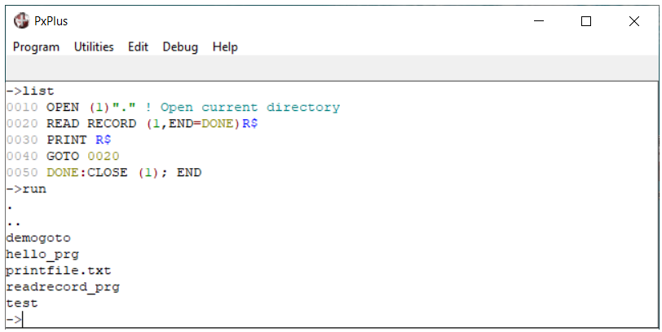
The WRITE RECORD directive writes the string specified in the parameter list to the file without the insertion of a field separator. If the file contains fixed length records, the WRITE RECORD statement will append nulls (Hex 00) to the record being written.

File Processing Functions
This table lists the 12 file processing functions, including the three that we have already mentioned, which are FIB( ), FIN( ) and FID( ).
All file processing functions expect a file number as the first argument.
FID( ) | Returns a description of characteristics of the file specified. Returns one of five formats depending on the 'FF' system parameter.
FIB( ) | Same as FID( ) but format always PxPlus standard format.
FIN( ) | Returns detailed physical aspects of the file specified.
IND( ) | Returns index of the next record in the file; will generate error at end-of-file.
KEC( ) | Returns the key of current (last read/written) record; will generate error at start of file.
KEF( ) | Returns the key of first record on the file; generates error if no records exist.
KEL( ) | Returns the key of last record on the file; generates error if no records exist.
KEN( ) | Returns the key of the record after the next record to be read.
KEP( ) | Returns the key of the previous record - keyed files only; generates error at start of file.
KEY( ) | Returns the key of next record; generates error at end of file.
RCD( ) | Returns the contents of record; equivalent to READ RECORD.
RNO( ) | Returns the record number of a specified record in key sequence.

Serial Files
Serial files are plain text files containing one or more records of variable length. Normal uses for Serial files are for holding print images, reports or for interchange with other operating system applications.
READ, WRITE, PRINT and INPUT directives may be used on a Serial file.
The syntax to create a Serial file using the SERIAL directive is:
SERIAL strexpr [, numexpr1 [, numexpr2]]
Where:
strexpr | A string variable; the name of the Serial (sequential) file to create.
numexpr1 | (Optional) Estimated number of records that the file is to contain.
numexpr2 | (Optional) Maximum size of the data portion of the record.
Example:
SERIAL "filename"
On a Serial file, the READ directive reads the file one record at a time, from beginning to end.
The WRITE directive appends to the end of the file. Any attempt to READ after a WRITE without having either closed the file or repositioned the pointer via IND= results in an Error #2 (END-OF-FILE on read or File full on write).
A Serial file must be LOCKed in order to WRITE.

Indexed Files
Indexed files may be accessed by index number. Each record on the file is assigned a record index, starting from 0. All records in an Indexed file are the same length. No keys are maintained for Indexed files.
The syntax to create an Indexed file using the INDEXED directive is:
INDEXED strexpr,[numexpr1], numexpr2 [, ERR=stmtref] [, SEP=character]
Where:
strexpr | A string variable or expression; the name of the file to create.
numexpr1 | (Optional) Estimated number of records that the file is to contain.
numexpr2 | (Optional) Size of the data portion of the record.
Example:
INDEXED "filename",,100
Indexed files support all Input/Output directives except the REMOVE directive. Whenever an Indexed file is read or written to, the current file position is updated to the record index selected. For example, if a read is issued for record index 80, a read of the next index returns record 81.
The READ directive without an index specified returns the record with the next record index. Attempting to READ a record whose index exceeds the highest index written results in an error.
A WRITE directive without an index specified overwrites the record with the next record index. Attempting to WRITE a record whose index exceeds the highest previously written results in all intermediary records being initialized with Hex zeroes except where the index specified exceeds the maximum record size for the file, in which case an error is returned.

Keyed Files
Keyed files contain at least one unique (primary key) field that identifies each record on the file - this is the most common file format used in PxPlus. This type of file may be accessed by any key field, by index, or sequentially. The record formats for keyed files may include FLR (fixed length records), VLR (variable length records), and EFF (enhanced file format). See Keyed Files in the PxPlus Help documentation.
Keyed files are also categorized according to how the key is being used:
Direct Consisting of an external key
Sort Consisting of keys but no data
Keyed Consisting of one or more keys
Keyed files support all Input/Output directives.
The READ directive without a KEY= option reads the record with the next higher key. When reading a file with an external key, it is normal to first retrieve the key of the next record:
k$=KEY(1,end=done)
read (1,key=k$)
The WRITE directive without a KEY= option is invalid unless the record was previously EXTRACTED (see Record Locking) or has an embedded key (see Multi-Keyed Files).
The REMOVE directive deletes the record whose key matches the key specified. When the record is deleted, its associated disk space is returned for re-use.
Accessing or attempting to access a record whose key does not exist positions the file pointer to the next higher existing key. The only exception is when using the FIND directive. This directive is a variation of the READ verb that does not update the current file pointer if the key is not found.

Direct Files
A Direct file is a keyed file with an external key. On the DIRECT directive, the key size must be specified along with the file name.
The syntax to create a Direct file using the DIRECT directive is:
DIRECT strexpr, numexpr1 [, numexpr2 [, numexpr3]][, ERR=stmtref]
Where:
strexpr | A string variable; the name of the Direct file to create.
numexpr1 | Length of the key for all records within the file.
numexpr2 | (Optional) Number of records.
numexpr3 | (Optional) Maximum size of the data portion of the record.  If negative, the data file is created with variable length records with the maximum record length being the positive value of this field.
Example:
DIRECT "CSTFLE",6

Sort Files
Sort files consist of a key only with no data record portion. Key size must be specified, along with the file name, on the SORT directive.
The syntax to create a Sort file using the SORT directive is:
SORT strexpr, numexpr1 [, numexpr2] [, ERR=stmtref]
Where:
strexpr | Name of the Sort file to create.
numexpr1 | Maximum key size to be maintained by this file.
numexpr2 | (Optional) Estimated number of records that the file is to contain.
Example:
SORT "CSTFLE",6

Keyed Files
The KEYED directive creates a file with 1 to 16 keys. The primary key can be external or internal. If the first field after the file name is a number, an external file key is created. If it contains a key definition (enclosed within [ ] (square brackets)), then only internal key fields may be used. The first key specified is considered the primary key.
The syntax to create a Keyed file using the KEYED directive is:
KEYED strexpr1,[,numexpr1][,strexpr2][,numexpr2[,numexpr3]]
[,BSZ=numexpr4] [, ERR=stmtref][, SEP=character]
Where:
strexpr | Name of the Keyed file to create.
strexpr2 | Defines key fields in the format.  The Keyed file can be single- or multi- keyed. A key definition is made up of one or more key field definitions ranging from 0 to 15 for FLR/VLR files or 0 to 255 for EFF files. Use integers for specific field numbers or 0 (zero) for record-based offsets. The key definition formats are as follows:  Single Key Field:  [["keyname":]field:offset:len[:"attr"]]  Composite Key Fields (using the + operator):  [["keyname":]field:offset:len[:"attr"] ]+[field:offset:len[:"attr"]]  Multi-Keyed Alternate Key Fields (are comma-delimited):  [["keyname":]field:offset:len[:"attr"] ],[["keyname":]field:offset:len[:"attr"]]  Where:
  keyname | Name of key assigned for use in KNO=name$ options
  field | Integer, 1 to number of fields (0 = record-based offset)
  offset | Starting position within the field (integer, 1 to 3839)
  len | Length, number of characters in the key field (integer)
  "attr" | Attribute characters
  : | (Colon) Separator for elements in a key segment.
numexpr1 | Length of the external key, if any.
numexpr2 | (Optional) Maximum number of records that the file is to contain.
numexpr3 | (Optional) Maximum size of the record, excluding key.  If the record size is specified as a negative, a variable length record data file is created with the maximum record length being the positive value of this field. If not specified, the file will contain variable length records with a maximum record size of 256.
Example:
KEYED "CSTFLE",6 (Creates a file with an external key)
KEYED “CSTFILE”,[1:1:4] (Creates a file with an internal key)
Multi-Keyed Files
A multi-keyed file is a keyed file with one primary record key and up to 15 secondary keys. The primary key must be unique within the file while the secondary keys may be duplicated between records (e.g. as in a name file where two JONES may exist).
A multi-keyed file is defined like any keyed file except that the key definition contains a series of comma-separated key declarations. The first key declaration is for the primary key; the remaining declarations are for the secondary keys.
Internal keys are defined as follows:
KEYED "CSTFLE",[1:1:6],[2:1:10],,500
A multi-keyed file may contain an external key and several internal keys:
KEYED “CSTFILE”,6,[1:1:6],[2:1:10],,500
If desired, a composite key can be generated using the + (plus) operator to concatenate several keys. The data fields will form a complete key:
KEYED "CSTFLE",6,[2:1:10]+[KEY:1:6]

Enhanced File Format
The Enhanced File Format (EFF) allows for single files up to 504 gigabytes in size. These are 64-bit and are intended for Large File System (LFS) operating systems that provide 64-bit file addressing and locking functions. Operating systems that do not provide 64-bit file functions are also able to read/write this format but only within a 2GB limit.
The CREATE TABLE directive is designed for creating EFF files on platforms that support LFS, 64-bit addressing. It uses the same syntax as the KEYED directive:
CREATE TABLE filename$,[,extkey_len][,key_def$][,max_recs][,rec_size][,fileopt]
EFF files can also be created with the KEYED directive by setting the 'KF' system parameter ("KF"=2) or by including OPT="2" in the syntax.

*Memory* File
A *memory" file is simply a memory resident queue of records that can be accessed by index or (external) record key. The functions KEY, KEP, KEL, KEF, KEN and IND will work with a memory file. You can also access *memory* files by record number (RNO). The record index will equal the logical placement of the records in key order sequence.
To create a memory file:
OPEN (ch) "*memory*"
To delete a memory file:
CLOSE (ch)
This will return memory to the system.
INDEXED Handling
To write to file:
WRITE (ch, IND=n) iolist
or
WRITE RECORD (ch, IND=n) strexpr
This will insert records at the specified point in the memory queue file. It will insert and not overwrite the existing records. If you currently have 5 records in the file and issue a WRITE (ch, IND=3), the record formerly at index 4 will now be at index 5.
To read a record:
READ (ch, IND=n) iolist
or
READ RECORD (ch, IND=n) strvar
To remove a record:
REMOVE (ch, IND=n)

KEYED Handling (as a DIRECT file)
To add/update a record:
WRITE (ch,KEY=key_value) iolist
or
WRITE RECORD (ch, KEY=key_value) strexpr
To read a record:
READ (ch,KEY=key_value) iolist
or
READ RECORD (ch,KEY=key_value) strvar
To remove a record:
REMOVE (ch,KEY=key_value)

Directory File Processing
Directory files represent the operating system directory tables, which maintain the list of files present in the system. PxPlus provides read access to these directory lists.
When a directory is opened, the records read from it contain the names of the files within the directory. The names are not returned in any specific order. The sequence of the entries within a directory is an operating system function.
To facilitate opening a directory, the INPUT option should be specified on the OPEN directive. PxPlus will not allow the user to write to a directory file.
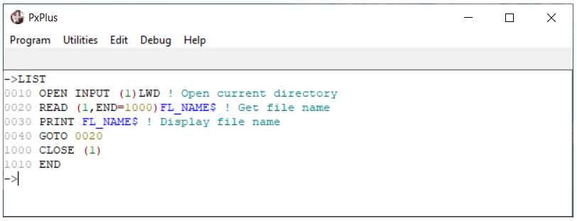

IOLISTs
Any Input/Output directive may include a common parameter list or IOLIST. This simplifies and reduces coding.
An IOLIST is a list of parameters to be used in an Input/Output directive.
To reference an IOLIST, include the IOL=lineref option:
0100 READ (1,KEY=K$) IOL=1000
0110 WRITE (1,KEY=K$) IOL=1000
The line reference refers to a line number or label where the IOLIST directive is found:
1000 IOLIST A,D,K(1),F$,F1$
An Input/Output directive or IOLIST may contain as many IOL= options as desired:

Defining IOLIST on OPEN
If you include the option IOL= within the OPEN statement, all further READ or WRITE statements will automatically use the one given in the OPEN. This can be overridden for individual READs or WRITEs, if desired:
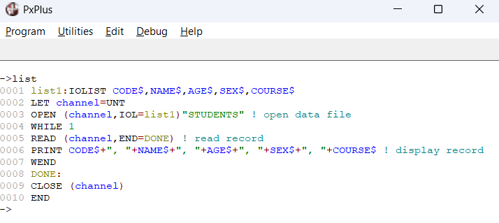
Variable IOLISTs
PxPlus allows you to use variables as IOLISTs. To use a variable as an IOLIST, it must first be initialized with the object code for the desired IOLIST. This can be accomplished via the CPL or PGM functions:
0100 IOL_1$=CPL("IOLIST A$,B$,D")
or
0100 IOL_1$=PGM(110)
0110 IOLIST A$,B$,D
Note:
Since a RENUMBER directive could change the line number of the IOLIST in the above example, we suggest that you use the following piece of logic:
0100 IOL_1$=PGM(TCB(4)+1)
0110 IOLIST A$,B$,D
It uses the function TCB(4) to get the current line number and then adds 1. When this is passed to the PGM function, the contents of the NEXT line will be returned, which should have the desired IOLIST. RENUMBERing will not affect this type of coding.
Once a variable has been loaded with the IOLIST, it is specified following the IOL= option rather than a line number or statement name:
READ (1) IOL=IOL_1$
One of the easiest ways to handle IOLISTs is to assign them during initialization to Global variables:
0100 %CST_IOL$=PGM(TCB(4)+1)
0110 IOLIST CST_NM$,CST_ADR$,CST_CITY$,..
This will allow you to easily change IOLISTs without having to make large-scale program changes. If desired, you could even open the files and assign them global file numbers.

Formatted IOLISTs
In addition to naming the variables, an IOLIST can also define the exact format of a data record. A format specification may be given immediately following the variable names on an IOLIST directive.
Format specifications should be separated from the variable name by a : (colon) and enclosed within [ ] (square brackets):
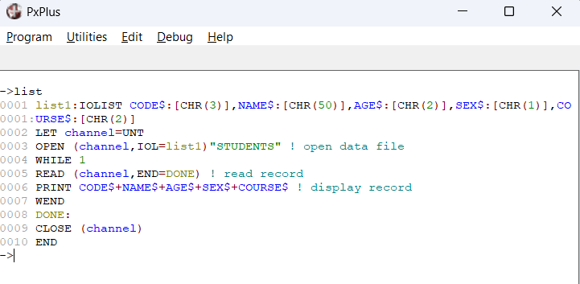
For information on formatted IOLISTs, see Input and Output Parameters in the PxPlus Help documentation.

Prefixing IOLIST Variables
Sometimes, when using common IOLISTs, it is desirable to temporarily override the variable names. The REC= option provides this capability:
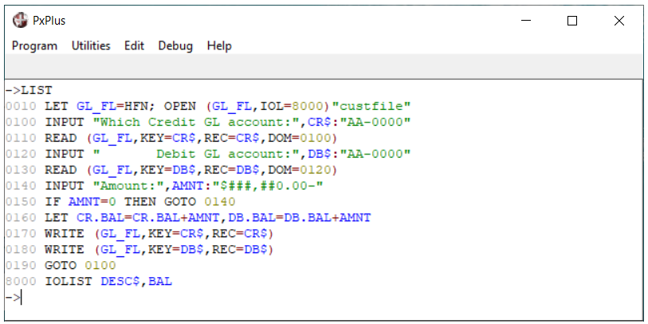
The variable name following the REC= is used to prefix all the variables in the IOLIST.
The variable specified must be a string variable.

The REC= option is used to maintain two separate records in memory. One record will have all its variables prefixed with DB. and the other will have the CR. prefix.

Composite Strings
PxPlus provides the ability to define strings as a collection of data elements called composite strings. A composite string is basically a record that is defined by an IOLIST.
The DIM directive is used to define a composite string.
Example:
0100 DIM X$:IOL=1000
...
1000 IOLIST A$,B$,X,Y
This example defines a composite string consisting of four variables. Variables referenced in a composite string will be prefixed with the name of the composite string. In this example, the variables that are referenced by X$ are not A$, B$, X, and Y but X.A$, X.B$, X.X, and X.Y. This is comparable to the REC= option.
Assigning data to a composite string causes the elements defined in the IOLIST to be loaded with their associated values. Referencing a composite string returns all the variables in their respective formats as defined by the IOLIST; thus, it can be considered a logical record or structure.
Given:
0100 DIM X$:IOL=1000
1000 IOLIST A$,B$,X,Y
The following code:
0120 LET X.A$="CAT", X.B$="DOG", X.X=1,X.Y=2
0130 PRINT X$
Yields:
CATsepDOGsep1sep2sep
The IOLIST specified general formatting of the data, so each field was placed in ASCII and output with a standard field separator.
See Composite Strings in the PxPlus Help documentation.

SELECT Directive (Select/Query From ... Where)
Use the SELECT directive to open, read and query records from the specified data file or just to read data from a specified file number.
As each record is read, PxPlus processes any logic you include following the SELECT directive up to the NEXT RECORD. When PxPlus encounters a NEXT RECORD statement with no records found for a nested SELECT, it will locate the corresponding SELECT statement.
If you include a WHERE clause, PxPlus will process only those records WHERE the condition is true. The BEGIN and END clauses are only supported for KEYED and MEMORY files.
Example:
0010 SELECT IOL=0100 FROM "CUST_FILE",KNO=1 BEGIN "ABC CO" END
"NEW CO" WHERE CITY$="CLARENDON"
0020 PRINT REC(IOL=0100)
0030 NEXT RECORD
0100 IOLIST CUST$, NAME$, ADDR1$, ADDR2$, CITY$, PROV$, POSTAL$,
INV_DT$, AMT, TERMS, DUE_DT$
0110 PRINT "DONE"; END
If you instruct PxPlus to exit the SELECT loop early (with an EXITTO directive), the file will be CLOSEd.

Exercises
Create a serial file using the SERIAL directive:
->SERIAL "ser"
Write 10 records to the "ser " file:
10 open lock (1) "ser "
20 for I = 1 to 10
30 write (1) "This is record "+str(I),"This is a field"
40 next I
50 print "done";close (1)
60 end
Preview the file in Notepad.
Create a serial "report" file from your "ser " file, as shown below:
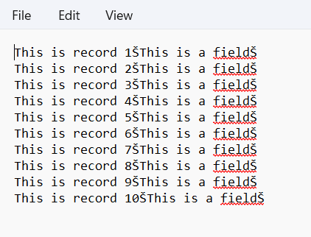

Create a file using the INDEXED directive and write records to the file. Preview using the utility *UFV:
->indexed "indy",,100
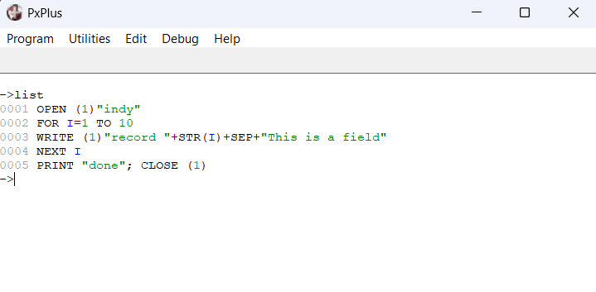
->load *ufv
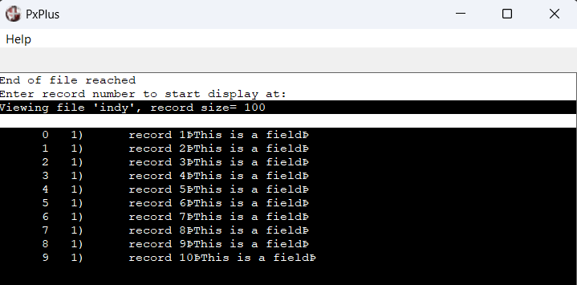

Use the *UFM utility to create a keyed file "custfile" with the following structure:
- Each record has four fields: cust_id, lastname, firstname, cust_bal
- Record size = 100
- Primary key is internal, key length = 6 (cust_id)
- Alternate key consists of the primary key plus the first 10 characters of the second field (lastname), key length = 16
Create an input program to load five records into the file.

Debugging Techniques
The Debugging Windows
The Windows version of PxPlus provides four special display windows that can be used to simplify program development and debugging. Access the Debugging Environment either by clicking the PxPlus icon in the top left corner of the PxPlus Command window or by pressing the key combination ALT+Spacebar and then D.
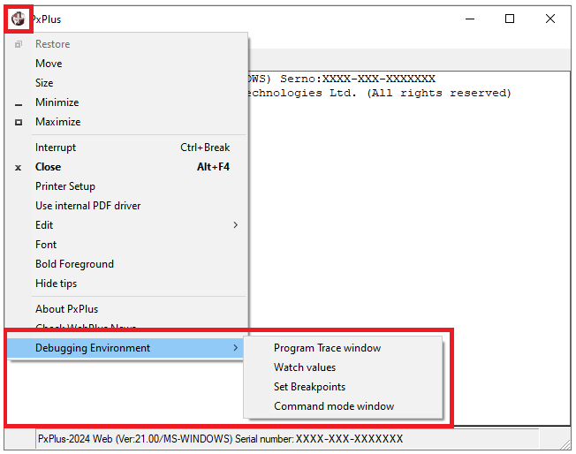
The Debugging Environment option provides access to the four debugging windows:
- Trace Window
- Watch Window
- Break Window
- Command Window
All except the Watch Values window can be set to auto-activate when the system starts. The Breakpoint and Watch Values windows can also be set to auto-load values.
Trace Window
The Program Trace window option is used to access the Trace Window, which displays lines as the program executes.
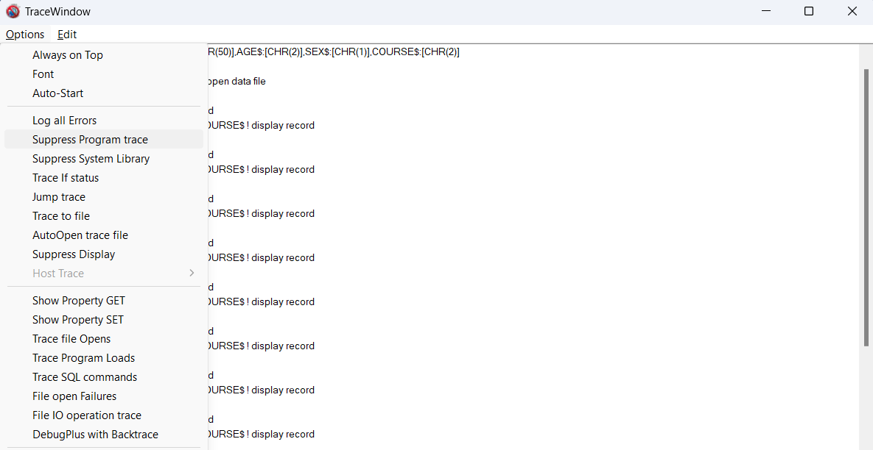

The Suppress Program trace option suppresses the display of program trace lines. This option can be effective when used with the Log All Errors option.

The Log All Errors option displays all error conditions detected, including error conditions (such as DOM) that may be handled within the application.

The Auto-Start option will initiate the program Trace Window any time PxPlus starts.

Other Options
The Edit menu provides other options that allow you to copy the trace information to the Clipboard or save to a file.

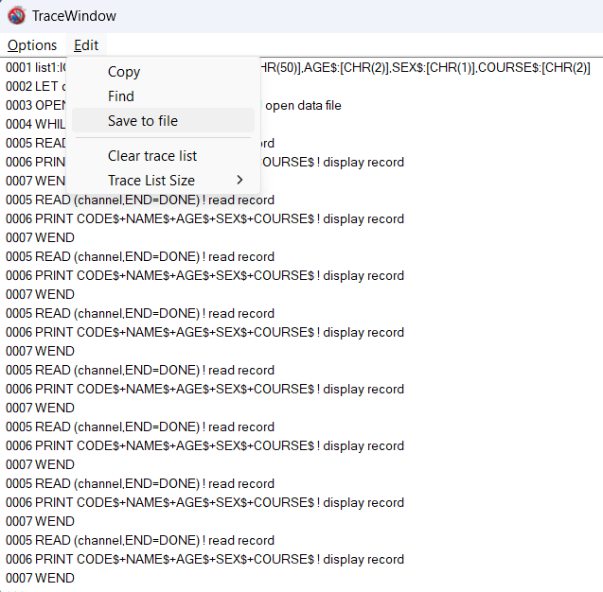

Watch Window
The Watch values option is used to access the Watch Window, which allows you to constantly monitor variables and/or expressions during program execution.
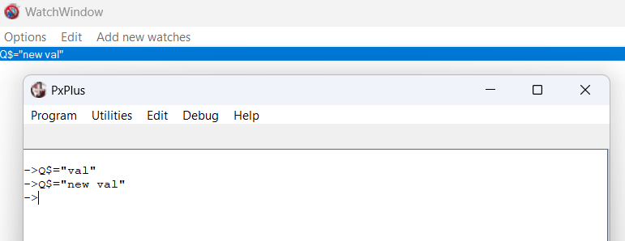
Other Options
The Edit menu provides other options that allow you to copy watches to the Clipboard or save to a file for subsequent reload.
The Options menu provides an Auto-Load option to automatically set a watch on a variable or expression each time PxPlus starts.
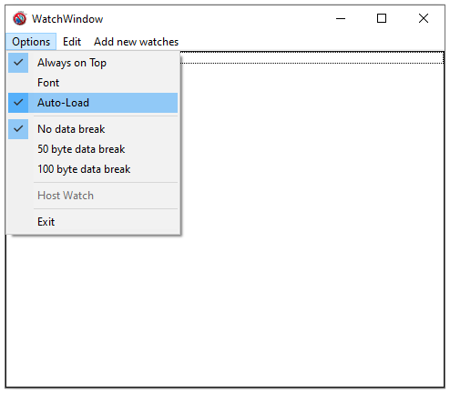
When the Always on Top option is selected, the Watch Window will appear in the foreground of the screen.
To use the Auto-Load option, you must have previously selected the Save to file option on the Edit menu.
Saved "watches" will automatically be monitored whenever the program runs.

Break Window
The Set Breakpoints option is used to access the Break Window, which allows you to assign points in your application where you wish to halt execution. You can specify the name of the program and a line reference and/or condition to test.
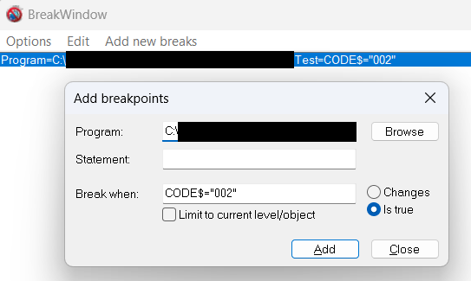
Execution halts when the Break condition is met:
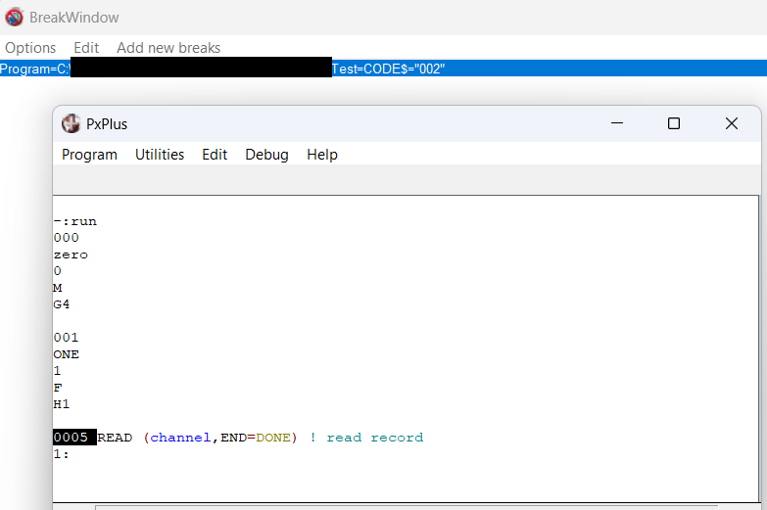

Command Window
The Command mode window option is used to access the Command Window, which is used to handle all console commands without disrupting standard screen display.
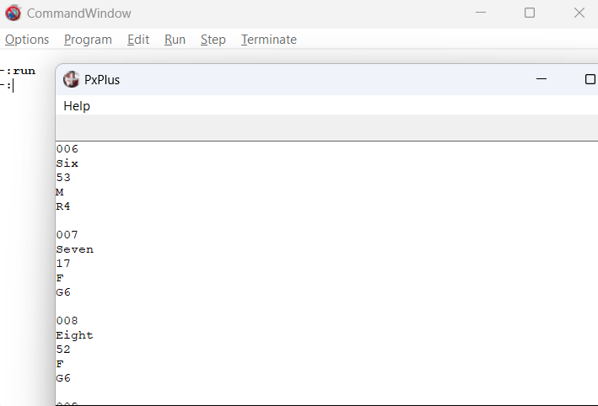

When PxPlus drops to Command mode at breakpoints, program lines display in the Command Window rather than on the screen.

Tracing a Program
The SETTRACE directive enables tracing of the program.
The trace output can be displayed on the user terminal or written to a file by specifying SETTRACE (n). Alternatively, it can be output directly to a trace window, if active.
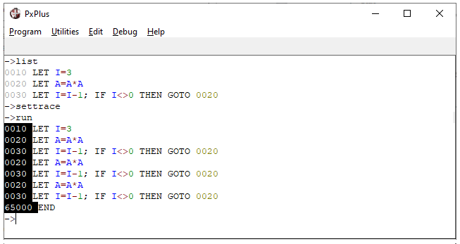
If a compound statement executes a GOSUB, FOR or WHILE directive as the final directive, it will appear twice in the trace - once when the directive is executed and once when control returns to the statement.
The trace remains active until an ENDTRACE is executed or the program terminates via END or STOP.
Tracing is suppressed during the execution of a password-protected program.
Single Step Execution
You can single step through a program by pressing F2 or by entering . (period) at the Command prompt. If you want to suspend single step execution until the end of FOR..NEXT GOSUB/RETURN, you can enter .. (double periods) prior to the start of the loop. To suspend single step execution during CALLed routines, type .. (double periods) immediately before the program executes the CALL statement.

Breakpoints
PxPlus allows a program to execute until it reaches a statement that contains a breakpoint. Breakpoints operate like ESCAPE statements but are preferred since they are not saved with the program. A program will drop to console mode when it reaches a breakpoint. Breakpoints must be entered from console mode while the program is in memory:
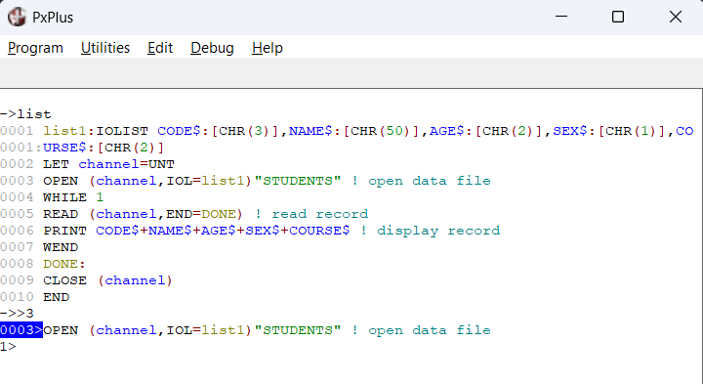
A single breakpoint is set by typing a > (greater than) symbol followed by a line number.
The program will immediately execute and stop when it reaches statement 3. A single breakpoint will remain set until it is removed by typing a > (greater than) symbol.

PxPlus currently supports up to 10 breakpoints per program. To define multiple breakpoints, enter a > (greater than) symbol followed by a + (plus sign) and then a line number.
Example:
>+100
>+200
>+300
This will set three breakpoints in the program. Setting multiple breakpoints does not cause the program to start or continue execution. Lines with breakpoints will be listed with blue line numbers and a > (greater than) symbol following the line number.
To remove one of several breakpoints, enter a > (greater than) symbol followed by a - (minus sign) and then the line number. Entering a > symbol will remove all breakpoints.
Note:
Breakpoints only remain in effect while the current program is running.

Error Processing
During program execution, PxPlus may detect various error conditions. Errors may be due to problems with program logic, invalid data, or status conditions (end-of-file, duplicate record, etc.). Typically, programs are designed to detect and process most errors anticipated in normal program operation.
Each error generates a code ranging from 0 to 127. When an error occurs, the ERR system variable is set to the value of the error code.
When an un-trapped error occurs, the program stops, and PxPlus returns to Command mode (unless the 'XT' parameter is set, in which case PxPlus simply terminates). The statement that generated the error is displayed, along with the error code and its associated message text.
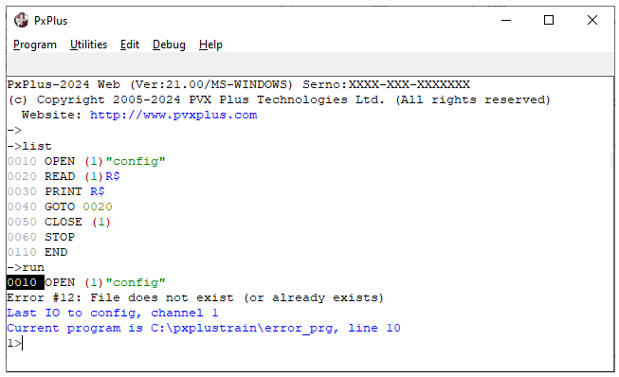
We will look at three complementary methods for dealing gracefully with errors:
- Error Transfer Option (ERR=)
- Error Handler Subroutine (SETERR directive)
- ERROR_HANDLER directive

Error Transfer Option (ERR=)
Most PxPlus directives for which errors are anticipated provide an error transfer option, as do all system functions. When a directive that includes an ERR= clause generates an error, control is transferred to the statement specified in the ERR= option:
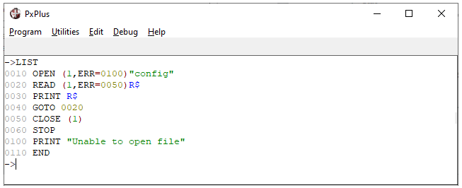
If an error occurs on the OPEN, control transfers to statement 0100. If an error occurs on the READ, control transfers to statement 0050.

Error Handler Subroutine (SETERR Directive)
Use the SETERR directive to define the transfer address for any error for which you have not used the ERR= option. While a SETERR is in effect, any error (divide check, subscript range error, etc.) transfers control to the statement number or label you specify in the SETERR directive.
Once the SETERR directive executes, any error not handled by an ERR= option will cause immediate transfer of control to the statement indicated on the SETERR. In the error procedure, the ERR system variable can be tested in order to determine the error and the action to be taken:
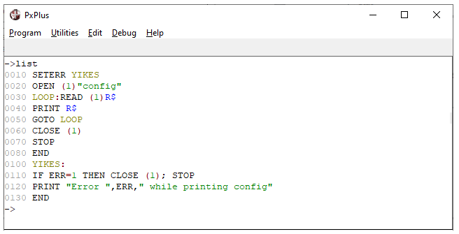
After a SETERR transfer occurs, PxPlus inhibits further SETERR transfers until either another SETERR is executed or a RETRY directive re-executes the statement that caused the error. This prevents system looping caused by errors in an error handler.
To disable the SETERR transfer, use statement number 0000 as your stmtref.

ERROR_HANDLER Directive
The ERROR_HANDLER directive specifies a generic error handler.
The syntax of the ERROR_HANDLER directive is:
ERROR_HANDLER [strexpr]
Where:
strexpr | Name of the error handler program. The ERROR_HANDLER directive without a program name provided cancels the current error handler.
The error handler program remains in effect until a START directive is executed or it is canceled.
To determine the program name of the error handler currently in effect, use the ERROR_HANDLER READ directive:
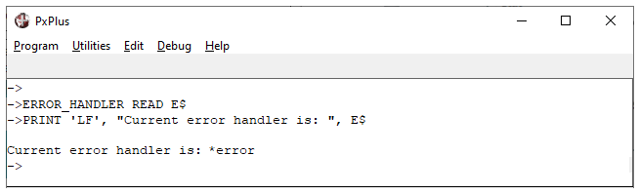
Typically, the error handler program is specified in the start_up initialization program (see the Tailoring the Environment section in this training manual). This error handler will be invoked automatically whenever an error is detected within a program that is not handled either by an ERR= option or a SETERR directive. The error handler allows the program and system designer to regain control in case of program failure.
When an error occurs, PxPlus will generate an internal CALL to the error handler. The error handler can retry the failing instruction, abort the session, or perform a normal error exit to return to Command mode where the problem can be fixed. The exact recovery to be done is determined by the error handler logic.
The sample program *ERROR can be used as a template for creating an error handler routine.

2. Advanced Programming

Introduction
This section introduces some of the more advanced features of PxPlus.
Topics in this section:
- Tailoring the environment using initialization procedures and system parameters
- Enhancing applications with PREFIX, START_UP and using Function and Control keys
- Learn to define custom functions
- Subprograms - CALL and PERFORM
- Overview of non-native file handling, including ODBC
- Introduction to mouse handling and windows programming concepts

User-Defined Functions
Defining Your Own Functions
PxPlus provides numerous system-defined functions that perform commonly used operations. In addition, you may define your own functions via the DEF FN directive. User-defined functions reduce redundant coding and simplify debugging and maintenance.
A function is defined only once, typically at the beginning of the program. During program execution, PxPlus will skip the DEF FN directive and then locate the function definition whenever the function is invoked.
The syntax of the DEF FN directive is:
DEF FN variable [(varlist)]=expression
Where:
variable | Any valid variable name, string or numeric. The function type is determined by variable type. FNvariable is the function name.
varlist | An optional list of variable names corresponding to those in the expression.
expression | A string or numeric expression. It defines the value of the function.  The expression does not have to refer to the variables specified in the parameter list. It can reference any constants, variables, system functions, or other user-defined functions.

To invoke a user-defined function, specify its name (FNvariable) followed by any parameters. At that point, the values in the varlist are assigned to the variables in the function definition:
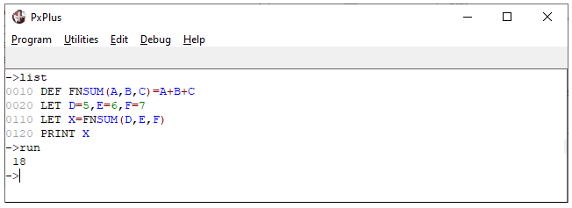
The values currently in D, E and F are passed to A, B and C and processed through the function.
Note:
Variables used in the function definition are actual variables in the program. Their values are subject to change each time the function is invoked. Therefore, we recommend that variable names used as parameters in the function definition not be used elsewhere in the program, or alternatively, variables may be defined as LOCAL to the function:
DEF FNSUM(LOCAL A, LOCAL B, LOCAL C)=A+B+C
User functions without parameters can be used like system variables:
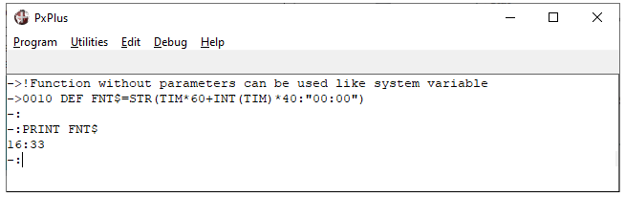

Multi-Line Functions
Multi-line functions are similar to the single expression functions mentioned previously except that they contain multiple lines. A multi-line function behaves like a GOSUB in that control is passed to the first directive following the DEF FN statement and continues until a RETURN value directive is executed. The value specified on the RETURN directive is the actual value that will be passed back to the expression that invoked the multi-line function.
When defining a multi-line function, the DEF FN directive is used without = expression. The multi-line function continues up to an END DEF directive:
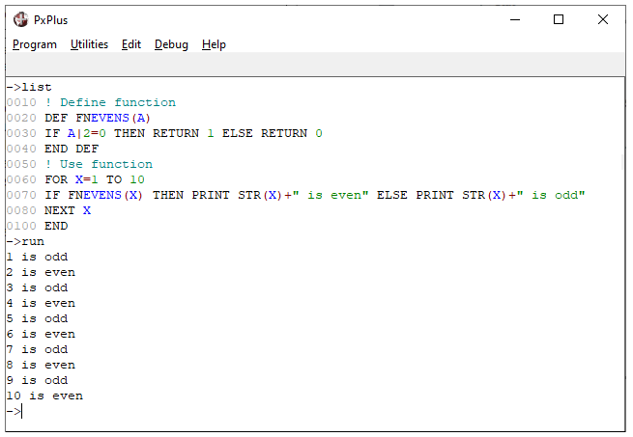
FNEVENS checks for even or odd numbers.
Even numbers return 1 to the function call; odd numbers return 0.

It is also possible to generate an error within a multi-line function by issuing an ESCAPE nnn where nnn is the error to be returned to the calling expression:
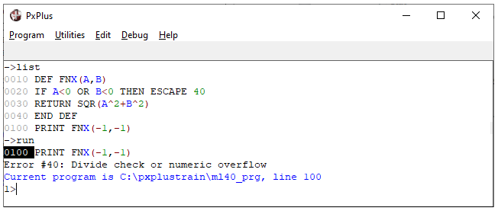
Issue an Error #40 if either side of the equation is true.

Global Functions
User-defined functions can be defined in one place and then shared by all programs within the application without having to recode them. Using global functions can reduce the size and complexity of your programs and simplify maintenance since common functions only need to reside in one place:
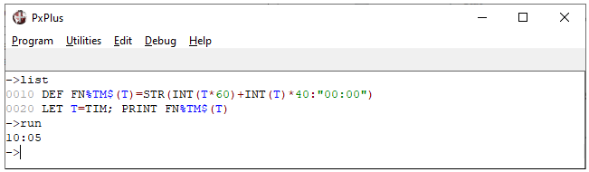
Once this DEF instruction is executed, the user function FN%TM$ is defined and is accessible to all programs for the duration of the user session or until a START is issued.

Subprograms
Subprograms can be used to perform common, repetitive processing. A subprogram is like a subroutine except that a subprogram exists as a completely separate program. When subprogram execution is complete, control passes back to the calling program.
A subprogram can be invoked by either the CALL or PERFORM directives. Either of these will save the current location in the calling program before loading and executing the subprogram.
Subprograms are terminated by the EXIT, END or STOP directives. The EXIT directive can optionally return an error condition to the program that invoked it. The END and STOP directives return control to the calling program.
Subprograms can initiate subprograms. No limit exists to the total of subprograms called, assuming memory is available. Each time a subprogram is started, the program level is incremented by one. When it terminates, the level is decremented accordingly.
The level number is displayed in the prompt line whenever program execution is halted. In addition, it is accessible via the TCB(12) function.
The program path name and line number are maintained in the program stack, which can be retrieved via the STK function:
0010 FOR LEVEL = TCB(12) TO 1 STEP -1
0020 PRINT STK(LEVEL)
0030 NEXT LEVEL
This example displays all entries on the subprogram stack, starting with the current level up to the mainline program level (1).
By default, when an unexpected error occurs within a subprogram. PxPlus returns the error condition to the CALLing program. If the 'NE' system parameter is set, the system will drop into Command mode while still in the subprogram.
A starting point within the subprogram can be specified when it is called by appending a ; (semi-colon) and the label name after the program name:
CALL "THISPROG; THATLABEL", A$, B$, C$
or
PERFORM "THATPROG; THISLABEL"

CALL and ENTER Directives
The CALL directive invokes a subprogram and passes it a list of arguments. The variables in a called subprogram are unique to the subprogram; i.e. CUST$ in the CALLing program has no relationship to CUST$ in the CALLed subprogram.
When the subprogram terminates, the CALLing program and its variables are restored, and execution resumes at the directive following the CALL.
The basic syntax of the CALL directive is:
CALL "progname",arg,arg,arg...
Arguments can be in the form of variables, literals or expressions.
The ENTER directive within the subprogram is used to receive the parameters. Each variable in the ENTER directive receives its value from the corresponding parameter value passed in the CALL directive:
ENTER arg,arg,arg
The values of the arguments in the main program will be passed to the subprogram and placed into the subprogram’s variables.
Subprograms can alter the value of the arguments passed to them. Simple variables passed as arguments become common between the main program and the subprogram; therefore, any changes to these variables in the subprogram will directly affect the value of the variable in the main program:
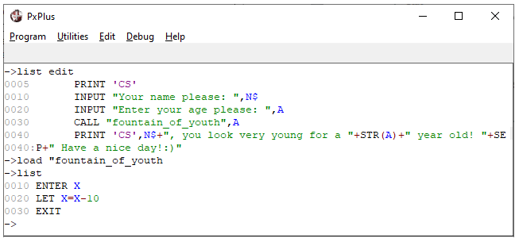
In the subprogram, the ENTER directive assigns the value passed from A to X. Any changes to X will affect the value in A.
PERFORM Directive
The PERFORM directive behaves like a cross between a RUN and a CALL. Like a RUN, it causes a new program to be loaded and passes all current variables to it, but like a CALL, returns control to the calling program when it completes.
In effect, the PERFORM directive can be considered an external GOSUB. A RETURN directive can be used to exit the PERFORMed program. This means existing GOSUB routines can be invoked from external programs, leading to greater modularization of applications and allowing for common programs and modules to be developed and only exist once in the system.
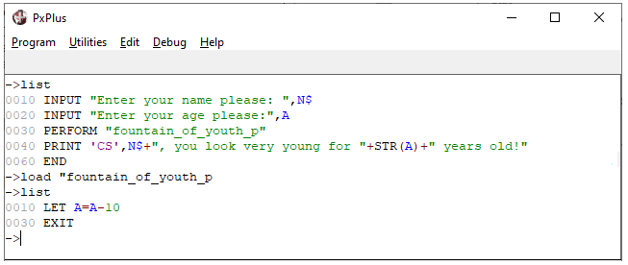

Advanced File Access
Foreign File Access
PxPlus provides read and write capability for files of all types. If a file is OPENed with the ISZ= option, it can be accessed as if it were an INDEXED file:
OPEN (1,ISZ=100) "CUSTDB"
The ISZ option specifies a logical record size for the file being opened. A file opened with an ISZ of 100 is treated as a series of 100 byte records. Record index 0 would consist of bytes 1 - 100, index 1 would be bytes 101 - 200, etc.
File contents can be read or written directly:
READ RECORD (1,IND=0, ERR=0060) R$
Access via the ISZ option is useful for reading and/or updating databases or files maintained by other applications. In addition, it can be used to provide direct access to disk contents in order to correct errors that may have occurred on a file.
Important Note:
Use the ISZ= feature carefully when updating files as there is no attempt by PxPlus to verify that the data you are writing is correct or proper for the type of file being updated. It is possible for you to accidentally corrupt data in your files if you update the file with the wrong data.

Dynamic Data Exchange (DDE)
Dynamic Data Exchange (DDE) allows your program to directly communicate with another Windows application and then access it like any other file. On the DDE OPEN, PxPlus will first try to establish communications with the specified application. If that fails, PxPlus will attempt to launch the application and then communicate with it.
The OPEN directive will establish communications with the specified application; e.g. Excel and optionally a Topic; e.g. book1:
OPEN (n)"[dde] Application|Topic"
or
OPEN (n) "[dde] Application;Topic"
Note:
The application must be found in the search PATH for PxPlus to be able to dynamically launch it, or you can use the SYSTEM_HELP directive, as shown in Example 1 below.
To read the value of an item, issue a READ RECORD with "Item" as the key. "Item" is the field/cell; e.g. "R1C1" (or to specify range, "R1C1:R3C3"):
READ RECORD (n,KEY="Item") R$
To update an item, use a WRITE RECORD command:
WRITE RECORD (n,KEY="Item") R$
See Examples 1 and 2 on the following pages.

Example 1 (Excel):
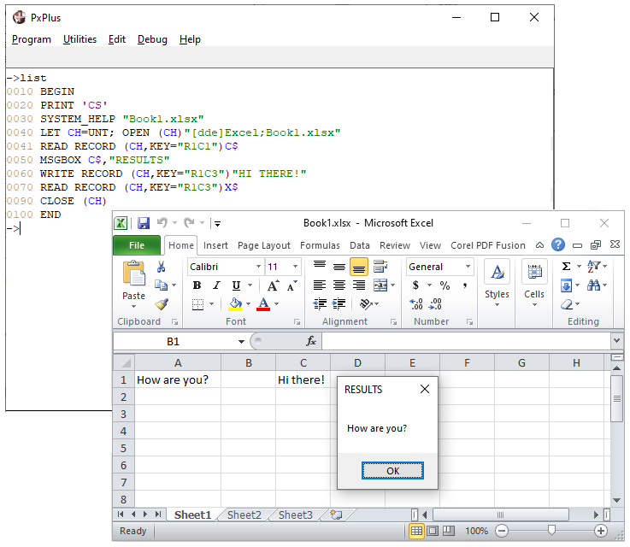

Example 2 (Word):
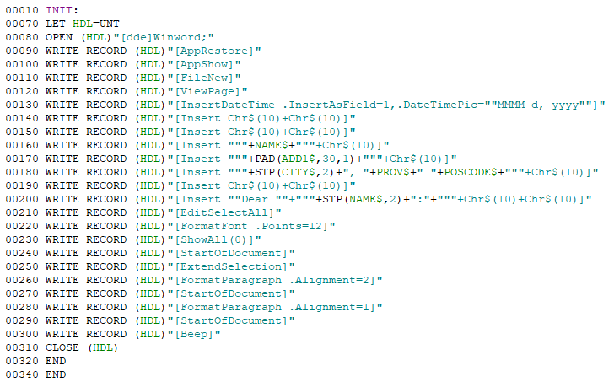
Assuming values in variables name$, add1$, etc., this program passes commands to Word to open and format a document.

Some DDE Servers allow for the submission of commands. A command can be sent to the DDE Server by issuing a WRITE RECORD without a key specified:
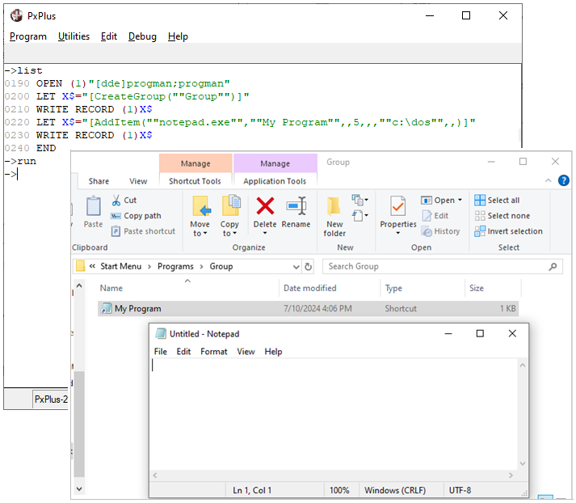
The example above modifies the Program Manager tables to add a new Group and Program Item.
The software being invoked determines the exact syntax for the commands being issued. Please refer to the documentation supplied with that product to determine how to communicate with it via a DDE link.

Dynamic Update Notification
To be advised when an item is changed within DDE, the program can associate a CTL value signal to be returned when an item gets altered:
0010 DEFCTL (dde_fileno) "Item"=ctl_event
The system will automatically invoke this event (generate a CTL value) whenever the value of the associated item changes.
Note:
This will not work with Excel more recent than version 4.0.

Open Data Base Connectivity (ODBC)
ODBC files can emulate keyed files if opened in the following manner:
OPEN (1) "[ODB]database;table;desc;desc;..."
Where:
database | Registered name of the ODBC database.
table | Dataset (file) within the database.
desc | (Optional) Parameters that allow the programmer to customize the way data will appear in the dataset. The parameters are:
  KEY=name,name,name | Defines the elements of a record key. First KEY= defines primary key.
  REC=name,name,name | Defines the fields of the dataset to return (and their order).  If no REC= option is given, all data fields are returned.
  PSWD=name | Defines the password of the file.
  USER=name | Defines user name as permitted in the ODBC administrator.
  NOSTRIP | Specifies that trailing spaces are not to be stripped from the fields.
All READ, WRITE and REMOVE statements function normally as PxPlus generates the SQL for you.
Note:
Some PxPlus functions will not work where ODBC does not have a corresponding function.

Alternatively, custom SQL statements can also be processed against ODBC files when OPENed without a dataset definition. READ statements can then be issued with the SQL command specified as a "KEY":
0010 OPEN (1) "[odb]Database"
0020 READ (1,KEY="SELECT * FROM CUSTOMER WHERE CUSTID > 'J'",
...
The fields retrieved will depend on the SQL command.
All ODBC system errors will be reported as "OS command failed" with the text of the error message available through the function MSG(-1). Errors such as "Record not Found" or "Duplicate Record" will be reported through normal PxPlus error handling.

Link and Device Files
PxPlus supports two special file types, Link files and Device files, that are basically pointers.
A Link file points to another file. A Device file points to a system peripheral device. Both contain the name of a Physical Device and an optional PxPlus Device Driver name.
These files consist of 256 bytes with the following information:
Bytes 1 - 8 | The value [Pvxlnk] for link files or [Pvxdev] for devices
Bytes 9 - 68 | File/Device name to use when the file is opened
Bytes 69 - 80 | Name of the Device Driver program
All other bytes should be left blank for future use by PxPlus.
When a Device or Link file is OPENed, PxPlus first attempts to open the physical device. Provided there are no problems opening the device, PxPlus proceeds to execute the Device Driver program, if one is specified.
The Device Driver program resides in the Lib/_dev directory and is used to establish the characteristics of the device. Its primary function is to load the device mnemonic table (and for a terminal, to define CTL key values). PxPlus includes a comprehensive set of terminal and printer Device Drivers. You can modify these or add your own to suit your needs.
Typical use of a Device file is to configure the system to define the printers LP, P1, P2, etc. A utility, *UCL, has been provided to create Device and Link files.

TCP/IP
TCP/IP is a communication mechanism that allows two computers or programs to communicate with each other. TCP/IP uses IP addresses to identify the computers at each end of the link. The IP address is usually stated as nnn.nnn.nnn.nnn where the value of nnn is between 0 and 255.
There are two types of TCP connections:
- Server or Host connection ("listener" or daemon)
- Client or Requestor connection
A socket opened as a host can talk to one or more clients at the same time. A socket opened as a client can only talk to the host that it is connected to.
A TCP connection is established between client and server computers. The client end of the connection requests a connection to a specific server by giving its IP address and a service/port identifier. On the host computer, an application establishes itself by identifying its service/port number, which typically ranges from 1 to 65535.
PxPlus has built-in support for TCP protocol. TCP connections in PxPlus can be either Server or Client style connections. TCP/IP support in PxPlus is available on Windows and on most UNIX/Linux platforms.

To OPEN a TCP/IP link, a file path name must be given which indicates whether the TCP file is a host port or a client connection.
To establish a TCP connection in PxPlus, the [TCP] tag is used in the OPEN statement:
OPEN(channel {,options})"[TCP]{server};socket{;tcpopts}"
The pieces of information are separated by ; (semi-colons).
Where:
options | Channel characteristics for the OPEN. Valid options are:
  ERR=stmtref | Error transfer.
  BSZ=num | Block size in bytes for the channel. This indicates the largest amount of data that may be sent to or received from the channel at one time.
  TIM=num | Time-out value.
server | (Optional) IP Address or DNS (Domain Name Services) resolvable name of the server to which you wish to connect.  If server is specified, the channel is a client connection.  If server is not specified, the channel is a host connection.
socket | TCP socket number to connect to.  If opening as a host connection, this is the socket number to which the host listens and the client connects.  If opening as a client connection, the socket number is the one on which the host is listening.  If socket is 0 or >65535, an unused socket number is assigned dynamically by the operating system.
tcpopts | Options to override default TCP characteristics. For a list of supported options, see [TCP] in the PxPlus Help documentation.

Example:
OPEN(chan,bsz=2048)"[TCP]mail.mydomain.com;110"
To create a host connection:
Do not specify the server, just specify ";socket"
OPEN (1) "[TCP];port"
To be a client:
Specify the server and socket number on the server.
OPEN (1) "[TCP]ip_addr;port;options"
After the TCP channel is OPEN, you can use it just like any other channel.
READ and WRITE
Follows the standard business basic rules, which append a SEP to the end of a WRITE and READs the data available and then parses it by SEP into variables on the READ.
READ RECORD and WRITE RECORD
Data is sent or read in binary form, no translation is performed, and no end-of-line terminator is appended or expected.
This table lists Input/Output functions, which will return meaningful information about the client that is connected to you:
KEY(channel)  or  FIN(channel,"IPADDR") | Returns the IP Address or DNS resolvable machine name of the client connected, which you last READ from.
KEF(channel) | Returns local information about the TCP channel. This is a semi-colon separated list of IP Address, socket number and machine name.
IND(channel) | Returns a numeric value that is a unique connection number for the client you last READ from.
See Example on the following page.

Example:
OPEN (chan,BSZ=8192)"[TCP];80" ! Listen to socket number 80 as a host.
LOOP:
READ RECORD (chan,END=CLIENT_DISCONNECTED,ERR=LOOP)indata$
LET unique_client_id=IND(chan) ! Note: 32-bit numeric value
LET client_id$=KEY(chan) ! Usually Client IP address; e.g. "172.16.1.1"
LET my_data$=KEF(chan) ! Local information on socket; e.g. "10.12.1.12;80;gord"
IF indata$="" \
THEN GOSUB NEW_CLIENT_CONNECTING
GOSUB PROCESS_DATA_FROM_CLIENT
GOTO LOOP
! CLIENT_DISCONNECTED:
LET unique_client_id=IND(chan) ! Note: 32-bit numeric value
GOSUB CLEAR_CLIENT_DATA
GOTO LOOP
! ETC…

WindX
WindX is a front-end presentation manager designed for use with PxPlus that runs under Microsoft Windows. It provides access to all the Windows capabilities of PxPlus through a mix of terminal emulation, remote processing functionality, and file-server facilities. With WindX, UNIX-based PxPlus applications can operate as if they are running directly in a Windows environment while continuing to execute on a UNIX host.
While WindX is primarily intended for use with UNIX hosts, Windows computers can also act as host application processors.
How Does WindX Work?
WindX and PxPlus work together in a client-server relationship wherein WindX performs the work of a presentation server for the PxPlus host application. When PxPlus is run from a WindX terminal, PxPlus will issue special transmission packets to invoke the Windows features that are requested by the application.
These features include:
- Direct access to Windows objects (Button, Check_Box, Tristate_Box, List_Box, etc.)
- Graphics output capabilities
- Full mouse support
- Full multi-media support
- Full DDE support
- Remote file access (Read/Write any file on the WindX PC)
Advantages of WindX
WindX allows Windows-oriented PxPlus applications to be run remotely over an asynchronous communications line. By using a modem, remote users can run PxPlus applications on a host computer as if they were directly connected to it.
In addition, the remote file access support built into WindX allows the host application to read or write data files that reside on the remote computer. When WindX is used in conjunction with ODBC, data files maintained by Windows-based non-PxPlus applications can be directly manipulated by the host.
Accessing Files Remotely
Programs that access files on the PC running WindX use the same commands that are used to access files on the host system. The only difference is in the path name used to OPEN the file. All files that are to be processed using the WindX remote file access facility must be prefixed with [WDX].
Example:
To read the file C:\CONFIG.SYS on the WindX PC:
OPEN (1) "[WDX]C:\CONFIG.SYS"
READ RECORD (1,END=9999) R$
...
CLOSE (1)
PxPlus will automatically re-route all file-processing requests for remote files to the WindX PC. This includes:
Directives:
OPEN | REMOVE
READ | CLOSE
WRITE
Functions:
KEY( ) | KEN( )
KEL( ) | IND( )
KEF( ) | RNO( )
KEP( ) | FIB( )
This means you can use KEYED or INDEXED files that reside on the PC.
WindX also supports access to DDE and ODBC files, such as:
OPEN (1) "[WDX][DDE]Excel;Sheet1.XLS"
or
OPEN (1) "[WDX][ODB]MEDBASE;Patient"
Note:
The current implementation does not provide for remote file creation or extraction. These are planned for future releases.

PREFIX Directive
Most applications need to maintain files and programs in more than one directory or disk drive. These can be referenced by the complete path name of the file (or program) but this is not recommended.
The PREFIX directive allows the user to specify a string of prefixes to be inserted into the front of all file name references.
The prefixes to be inserted are provided as a string to the PREFIX directive with a blank as a separator:
Example:
0010 PREFIX "DATA/ PROGS/"
0020 OPEN (1) "ARDATA"
ARDATA would be searched for first as DATA/ ARDATA, then PROGS/ ARDATA, and then as ARDATA. The first occurrence of a file found with the name specified would be used.
On a FILE CREATE directive, if PREFIX is set, PxPlus will search for the file with all possible prefixes before considering the file non-existent and proceeding with the creation. If the file cannot be created in the first directory (permissions denied or no such directory), it will try to create the file in the next directory.
The PFX system variable and PFX( ) system function will return the current setting of the PREFIX directive and can be used to extend the PREFIX search rules:
Example:
0010 PREFIX "TESTDATA/ "+PFX
The use of prefixes should be limited to just one or two at most with the first entries being the most likely entries to return the file desired. Keep in mind that since PxPlus will try to open the file using each prefix until the request is satisfied, much time and Input/Output overhead will be wasted if a long list of prefixes is used.

Program Prefix
A special prefix may be defined within PxPlus specifically for use when accessing programs. Using a program prefix can increase system performance by reducing the time it takes to locate and load a program.
This prefix is defined by:
PREFIX PROGRAM "prefix_string"
Once a program prefix is defined, it will be the first prefix used for all LOAD, RUN, CALL, PERFORM, PROGRAM and SAVE directives. After the program prefix has been searched, any other prefixes will be checked. All other file accesses will search the other prefixes first and then the program prefix.
The current setting of the program prefix may be obtained via the PFX(PGN) function.

Dynamic Prefix Assignment
In many systems, the file and program names are standardized - the leading two or three characters indicate the subsystem or application that the program/file belongs to. For example, ARHIST or ARINFO would belong to the Accounts Receivable subsystem.
The PREFIX directive allows for the automatic separation of these files based on the first characters. Substituting the = (equals sign) character in the PREFIX directive causes PxPlus to take the first character of the file name.
Example:
0010 PREFIX "==/"
…
0100 OPEN (1) "ARDATA"
0110 OPEN (2) "CSTDTA"
…
0300 RUN "ARPOST"
The following searches would be performed:
File | 1st Search | 2nd Search
ARDATA | AR/ARDATA | ARDATA
CSTDTA | CS/CSTDTA | CSTDTA
ARPOST | AR/ARPOST | ARPOST
Prefix File
You can use the PREFIX file to do dynamic translations of file names using a KEYED file as a lookup table. The Prefix file consists of a file name, which is the key, and a data portion, which is the path to the file. Prefix files must be variable length.
Creating the PREFIX file:
KEYED "PVX_PFXF",15
Set search rules using PREFIX file:
PREFIX FILE "PVX_PFXF"

Function and Control Keys
CTL Variable
All input in PxPlus is terminated by the CTL variable. Positive CTL values (0 - 32767) are always returned to the application program.
Example:
This code will return positive CTL values:
0010 INPUT *
0020 PRINT CTL
0030 IF CTL=4 THEN END ELSE GOTO 0010
PxPlus handles negative values internally. CTL values from -1 to -9 and below -1000 are used by the PxPlus input editor to signal editing keys (Left arrow, Right arrow, etc.).
See Negative CTL Definitions in the PxPlus Help documentation.
Normal input editing can be overridden by using the 'BI'/'EI' mnemonics, in which case, the program will receive negative CTL values directly:
0010 INPUT 'BI',*,'EI'
0020 PRINT CTL
0030 IF CTL=4 THEN END ELSE GOTO 0010
This intercepts and prints the CTL value of any edit key. Edit keys will therefore not function.
Alternately, 'ME'/'MN' (Mode Edit and Mode Normal) can be used instead of 'BI'/'EI'. This will pass back values, which are invalid to the situation; e.g. Up arrow on an input.

DEFCTL Directive
PxPlus allows the mapping of function and control key sequences into CTL values via the DEFCTL directive. The DEFCTL directive is used to define a CTL value to be returned when the user enters a key or key combination.
Example:
0010 DEFCTL $09$=6
In this example, the TAB key has an EOM value of $09$. The DEFCTL directive assigns a CTL value of 6 to the TAB key.
To find the Hex values keys and key combinations:
0010 INPUT 'bi',*'ei'
0020 PRINT " eom= $"+hta(eom)+"$"
0030 IF CTL=4 THEN END ELSE GOTO 0010
Normally, the DEFCTL tables are maintained by *UCK in the file *KYBRD.CFG. This is loaded during device initialization by the program "*TTY". Settings can be viewed by running *UCK or through the Utility/Configure/Keyboard utility.
PxPlus ships with standard definitions for most terminals.

User-Defined CTLs
CTL values between -10 and -999 will cause the system to automatically call user-defined and developed programs. These programs must have the name $CTL-nnn where -nnn is the CTL value:
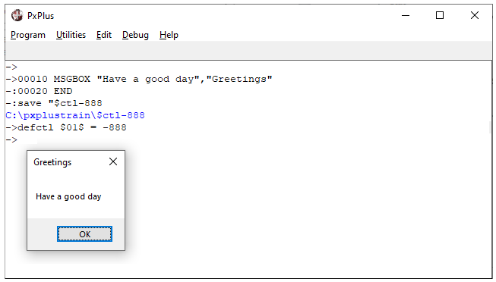
This program will run in response to the user entering the key combination CTRL+A ($01$).
Prior to executing this program, the screen will be saved. It will be restored once the program terminates. $CTL-nnn programs must not change the status of any open files in order not to affect a program currently being loaded or executed by the system.

PREINPUT Directive
The PREINPUT directive allows a program to prime the input buffer for the user terminal with the value contained within a string. It also allows the program to set the CTL value to be returned. Optionally, the CTL value only may be placed in the buffer.
The syntax of the PREINPUT directive is:
PREINPUT strexpr [, numexpr]
PREINPUT numexpr
Where:
strexpr | String which is to be placed into the input queue for the user terminal.
numexpr | (Optional) Value to be placed in CTL when the input is processed.
Multiple PREINPUT directives can be issued with the messages queued so that the first PREINPUT data will be processed first. This directive allows subprograms to respond to INPUT statements in the caller or subsequent programs.
PREINPUT NEXT Directive
When you use PREINPUT NEXT, PxPlus inserts your PREINPUT entry at the front of the queue.

Mouse Handling
SETMOUSE Directive
The SETMOUSE directive defines specific regions of the screen or text strings where mouse actions return CTL values or EXECUTE directives.
The syntax of the SETMOUSE directive is:
SETMOUSE [*] @ (col,line,width,height){=|:}{value}
or
SETMOUSE[*] text_string{=|:}{value}
If the : (colon) is used, the value is processed on mouse press or drag.
The = (equals sign) will process the value on mouse release.
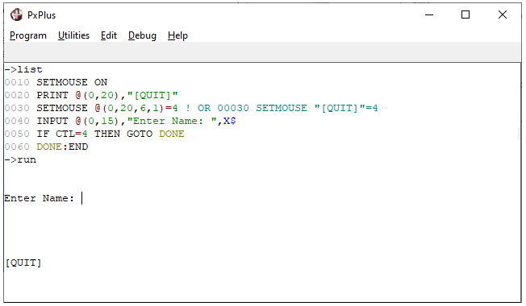

The standard PxPlus input handler intercepts mouse clicks and generates a pseudo input terminator (EOM value):
Mouse Action | EOM Value
Left button pressed or held and moved | $00FF01$
Left button released | $00FF81$
Right button pressed or held and moved | $00FF02$
Right button released | $00FF82$
Center button pressed (3 button mouse only) | $00FF04$
Center button released | $00FF84$
These EOM values may be assigned to a CTL value for the purposes of interfacing to a program.
Three special CTL values are provided to interface the mouse to your program. They are:
Mouse Action | CTL Value
Mouse button pressed/dragged | CTL 1080
Mouse clicked | CTL 1081
Mouse generated ESCAPE | CTL 1082
The default setting for PxPlus is to map the following:
Mouse Action | EOM Value | CTL Value
Left mouse button down/moved | $00FF01$ | -1080
Left mouse button released | $00FF81$ | -1081
Ignore right button down/move | $00FF02$ | -1000
Return CTL value 4 on right release | $00FF82$ | 4
Ignore center down | $00FF04$ | -1000
Call utilities on center release | $00FF84$ | -1

Tailoring the Environment
The PxPlus environment is dynamic - it can be altered, devices can be added or changed, and other aspects of the system can be modified without terminating PxPlus and returning to the operating system. PxPlus provides system parameters through which the environment can be customized - settings, default operating modes, as well as environmental emulation modes.
All PxPlus parameters are defined as two-character mnemonic-like codes that are used to control the execution of programs and the overall PxPlus environment. Each parameter is either an On(1) or Off(0) toggle or contains a value. Some parameters are mutually exclusive. For a list of all system parameters and their descriptions, see System Parameters in the PxPlus Help documentation.
To find current parameter settings, the PRM system variable and PRM system function are used:
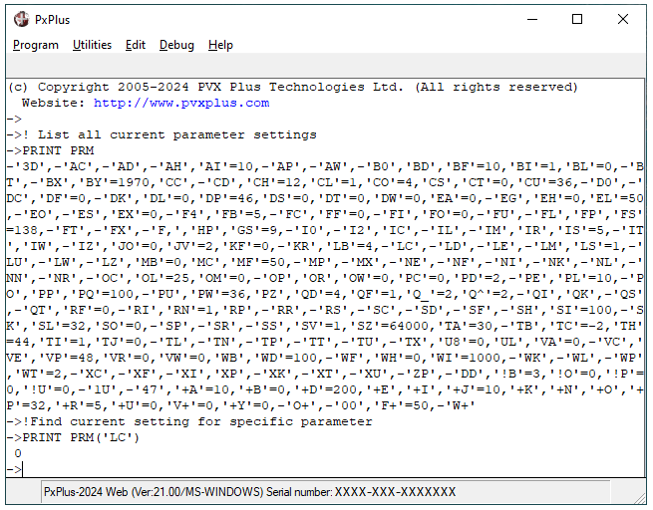
Use the PRM system function to print the setting of the 'LC' parameter: 0 = Off, 1 = On.
If the parameter passed to the PRM system function does not exist, it will return -1; otherwise, a positive value.
Print the PRM system variable to view all current parameter settings.
Parameters can be set or reset by using either of two methods:
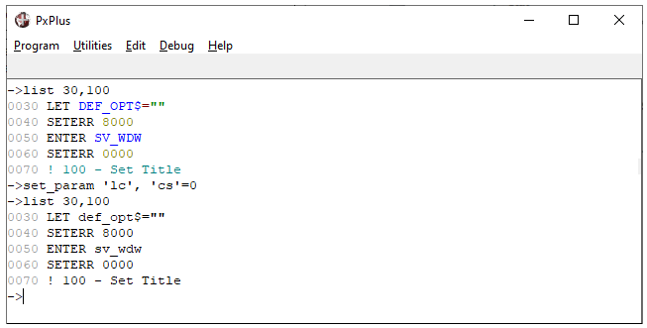
To set a parameter to On, enter:
SET_PARAM 'xx'
or
SET_PARAM 'xx'=1
To reset a parameter, enter:
SET_PARAM -'xx'
or
SET_PARAM 'xx'=0
To preserve and subsequently reset system parameters, the following may be used:
0100 SV_PRM$=PRM
...
9000 EXECUTE "SET_PARAM "+SV_PRM$
This saves all current parameters into SV_PRM$ before making changes to parameter settings within the program and then executes the SET_PARAM directive with the saved settings.
or
0100 SV_AH=PRM ('AH')
...
9000 SET_PARAM 'AH'=SV_AH
(Preferable method)
This saves a single parameter into SV_AH and resets that parameter only.

Parameters may be specified on the PxPlus Command line when PxPlus is loaded, in which case parameters are prefixed with a - (dash) or / (slash):

PxPlus does not check the validity of the parameters specified. Invalid and undefined parameters are ignored by the system.
System Environment Variables
PxPlus maintains a set of operating system-level environment variables that can be used to define and control various aspects of its current working environment.

Variable | Description
PVXEDIT | Editor used to maintain online program help information.
PVXFID0 | Value to return as FID(0).
PVXFLMAP | File name change map. This map consists of a series of two-character codes. When the first character is found in a file name, it is substituted by the second character.
PVXLIB | Location of the PVX Plus library directory.
PVXTMP | Name of the directory where temporary files will be placed. (Default is the current directory.)
For a complete list, see Environment Variables in the PxPlus Help documentation.

pxplus.ini File (Windows Only)
The pxplus.exe will allow the programmer to define the PxPlus environment through the use a "flat text" file with the .ini suffix. The file format must adhere to the standard format of the Windows .ini file in that it can contain headers enclosed in [ ] (square brackets) and parameters, each with a name, an = (equals sign) and an associated value.
The .ini file must be passed to PxPlus as the first parameter on the PxPlus Command line following pxplus.exe. This file will then be used to load and maintain current environment settings.
If no .ini file is specified, PxPlus will use the pxplus.ini file in the Windows directory.
This table lists some of the parameters for use in a PxPlus .ini file:

[Config] Section
Library=path | Must contain the path name to the PxPlus library location (e.g. ".. pxplus\Lib").
Fid0=text | This will override the setting of FID(0).
Icon=text | Name of the icon that PxPlus will display when the windows are minimized (e.g. Icon=ICON1).
ResourceLib=lib.dll | If you wish to include your own resources (bitmaps and icons), this is the name of the resource library (DLL). This library will be searched first for the application ICON and all '!' bitmaps.
CommandLine=text -prm -prm …. | Optional argument used to define the Command line to be used when running PxPlus. Used only when an .ini file is specified. Its contents replace the .ini file name in the original command sequence.
Debug=n | Debug=1 turns on support for the Debugging Environment windows.
[WindowFrame] Section
TypeSizeLoc=1,649,467,66,66 | Defines the screen mode, size and position. Updated automatically by PxPlus when the session terminates.
Caption=text | This is the default caption line to appear on the PxPlus main window.
ToolBar=nnn | This allows the developer to change the size of the toolbar. By default, the toolbar is set to the same size as the Windows caption boxes. Its size can be overridden by this parameter.
MessageBar=nnn | This allows the developer to change the size of the message bar. By default, the message bar is set to the same size as the Windows caption boxes plus a few pixels to allow for the 3D effect.
[Font] Section
Name=text | Name of the default fixed-width font (e.g. Name=Courier New).
Points=12 | Default fixed-width font size.
Charset=0 | Character set (0=ANSI). Do not change!
Bold=0 | 1 | Bold toggle. If set to 1, all foreground data will be displayed as Bold.
LockFont=0 | 1 | Font locking. If set to 1, the user may not change the fixed-width font from the system menu (button in top left corner of the screen).
For a complete list of parameters, see INI Contents in the PxPlus Help documentation.

START_UP (Initialization Program)
Initialization will occur whenever a user invokes PxPlus or issues a START directive. During initialization, PxPlus executes the general system startup program, *start.up, which, in turn, CALLs a user-developed program called START_UP, if it exists.
Some of the typical uses of a START_UP program are:
- Set system parameters
- Open global files
- Define global variables/global functions
- Set PREFIX
- FID assignment
Sample START_UP program:
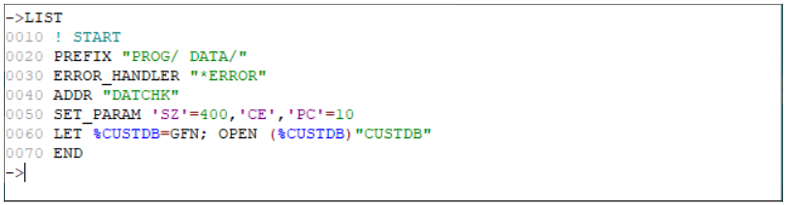
Once the initialization program has completed execution, PxPlus will load and run a lead program if specified on the Command line. The initialization procedure should not execute the application directly. Attempting to do so will cause PxPlus to incorrectly report application errors.

*CMD Command Line Routines
Command line shortcuts allow a programmer to effectively create new "directives". These shortcuts are simple PxPlus programs stored in a directory called *cmd (or /Lib/_cmd). The name of the program/shortcut cannot match any directive in the language (i.e. READ or LIST). It must also start with a letter.
When the name of the shortcut is entered in console mode, PxPlus compiles the line. If the line would normally generate an Error 20, PxPlus will check the *cmd directory for a program of the same name as the command that caused the Error 20. Any arguments typed after the program name will get passed down into a single variable.
DELETE
0010 ENTER X$,ERR=*NEXT
0020 IF X$="" THEN X$=STK(0), X$=X$(6)
0030 PRINT "Okay -- I ruined ",X$ 0040 END
SAVE "*CMD/RUIN"
When you type: RUIN "PROGRAM"
The response will be: Okay -- I ruined PROGRAM

3. Reference

Graphical Controls
Button Control
BUTTON [*] ctl_id, @(c,l,w,h)=strexpr1 [ , MSG=strexpr2] [ ,TIP=strexpr3] [ , ERR=stmtref ]
BUTTON {REMOVE|DISABLE|ENABLE} [*] ctl_id [ , ERR=stmtref ]
BUTTON {GOTO|HIDE|SHOW|ON|OFF} [*] ctl_id [ , ERR=stmtref ]
BUTTON READ [*] ctl_id, strvar [ , ERR=stmtref ]

Check_Box Control
CHECK_BOX [*] ctl_id, @(c,l,w,h)=strexpr1 [ , MSG=strexpr2] [ ,TIP=strexpr2][ ,TBL=setrexpr2]
[ , ERR=stmtref ]
CHECK_BOX {REMOVE|DISABLE|ENABLE} [*] ctl_id [ , ERR=stmtref ]
CHECK_BOX {GOTO|HIDE|SHOW|ON|OFF} [*] ctl_id [ , ERR=stmtref ]
CHECK_BOX READ [*] ctl_id, strvar [ , ERR=stmtref ]

Drop_Box Control
DROP_BOX ctl_id, @(c,l,w,h) [ , MSG=strexpr1] [ , KEY=strexpr2 ]
[ , FNT=strexpr3 ][,TIP=strexpr4][ ,TBL=strexpr4][ , ERR=stmtref ]
DROP_BOX {REMOVE|DISABLE|ENABLE} ctl_id [ , ERR=stmtref ]
DROP_BOX {GOTO|HIDE|SHOW|AUTO} ctl_id [ , ERR=stmtref ]
DROP_BOX LOAD ctl_id strexpr4 [ , ERR=stmtref ]
DROP_BOX LOAD ctl_id strvar1{ALL} [ , ERR=stmtref ]
DROP_BOX LOAD ctl_id , numexpr1 , strexpr5 [ , ERR=stmtref ]
DROP_BOX FIND ctl_id , numexpr1, strvar2 [ , ERR=stmtref ]
DROP_BOX READ ctl_id, strvar2 [ , strvar3 ] [ , ERR=stmtref ]
DROP_BOX READ ctl_id, numvar1 [ , strvar3 ] [ , ERR=stmtref ]
DROP_BOX WRITE ctl_id, strexpr5 [ , ERR=stmtref ]
DROP_BOX WRITE ctl_id, numexpr1 [ , ERR=stmtref ]
DROP_BOX SET_FOCUS ctl_id , alt_ctl_id [ , ERR=stmtref ]

Horizontal Scrollbar
H_SCROLLBAR ctl_id, @(c,l,w,h) [ ,TIP=strexpr1][ , ERR=stmtref ]
or H_SCROLLBAR ctl_id WINDOW [ ,TIP=strexpr1][ , ERR=stmtref ]
H_SCROLLBAR {REMOVE|DISABLE|ENABLE} ctl_id [ , ERR=stmtref ]
H_SCROLLBAR {GOTO|HIDE|SHOW} ctl_id [ , ERR=stmtref ]
H_SCROLLBAR WRITE ctl_id, numexpr1, numexpr2[ , ERR=stmtref ]
H_SCROLLBAR READ ctl_id, numvar, numexpr2, [ numexpr3, [ numexpr4 ] ]
[ , ERR=stmtref ]

List_Box Control
LIST_BOX ctl_id, @(c,l,w,h) [ , MSG=strexpr1] [ , KEY=strexpr2 ] [ , FNT=strexpr3 ]
[ ,TIP=strexpr4][ ,TBL=strexpr5][ , ERR=stmtref ]
LIST_BOX {REMOVE|DISABLE|ENABLE} ctl_id [ , ERR=stmtref ]
LIST_BOX {GOTO|HIDE|SHOW|AUTO} ctl_id [ , ERR=stmtref ]
LIST_BOX LOAD ctl_id strexpr4 [ , ERR=stmtref ]
LIST_BOX LOAD ctl_id strvar1{ALL} [ , ERR=stmtref ]
LIST_BOX LOAD ctl_id , numexpr1 , strexpr5 [ , ERR=stmtref ]
LIST_BOX FIND ctl_id , numexpr1, strvar2 [ , ERR=stmtref ]
LIST_BOX READ ctl_id, strvar2 [ , strvar3 ] [ , ERR=stmtref ]
LIST_BOX READ ctl_id, numvar1 [ , strvar3 ] [ , ERR=stmtref ]
LIST_BOX WRITE ctl_id, strexpr6 [ , ERR=stmtref ]
LIST_BOX WRITE ctl_id, numexpr1 [ , ERR=stmtref ]
LIST_BOX SET_FOCUS ctl_id , alt_ctl_id, [ , ERR=stmtref ]

Menu_Bar
MENU_BAR ctl_id, strexpr1 [ , ERR=stmtref ]
MENU_BAR READ strvar [ , ERR=stmtref ]
MENU_BAR {CLEAR|RESET|GOTO} [ , ERR=stmtref ]
MENU_BAR {ENABLE | DISABLE|ON|OFF} strexpr2 [ , ERR=stmtref ]

Multi_Line Input
MULTI_LINE ctl_id, @(c,l,w,h) [ , MSG=strexpr1] [ , KEY=strexpr2 ] [ , FNT=strexpr3 ]
[ , LEN=numexpr1] [ , DLM = strexpr4 ] [ , TIP=strexpr5] [ , FMT = strexpr6]
[ , ERR=stmtref ]
MULTI_LINE {REMOVE|DISABLE|ENABLE|AUTO} ctl_id [ ,ERR=stmtref ]
MULTI_LINE {GOTO|HIDE|SHOW|LOCK|UNLOCK} ctl_id [ ,ERR=stmtref ]
MULTI_LINE READ ctl_id, strvar1 [ , strvar2 ] [ , ERR=stmtref ]
MULTI_LINE WRITE ctl_id, strexpr5 [ , ERR=stmtref ]
MULTI_LINE SET_FOCUS ctl_id , alt_ctl_id, [ , ERR=stmtref ]

Radio_Buttons
RADIO_BUTTON [*] ctl_id:sub_id, @(c,l,w,h)=strexpr1[ , MSG=strexpr2] [ ,TIP=strexpr3]
[ ,TBL=strexpr4] [ , ERR=stmtref ]
RADIO_BUTTON {REMOVE|DISABLE|ENABLE|ON|OFF] [*] ctl_id:sub_id [ , ERR=stmtref ]
RADIO_BUTTON {GOTO|HIDE|SHOW} [*] ctl_id:sub_id [ , ERR=stmtref ]
RADIO_BUTTON READ [*] ctl_id, numvar, strvar[ , ERR=stmtref ]

Tristate_Box/Buttons
TRISTATE_BOX [*] ctl_id, @(c,l,w,h)=strexpr1[ , MSG= strexpr2] [ ,TIP=strexpr3
[ ,TBL=strexpr4][ , ERR=stmtref ]
TRISTATE_BOX {REMOVE|DISABLE|ENABLE] [*] ctl_id [ , ERR=stmtref ]
TRISTATE_BOX {GOTO|HIDE|SHOW|ON|OFF} [*] ctl_id [ , ERR=stmtref ]
TRISTATE_BOX READ [*] ctl_id, strvar [ , ERR=stmtref ]

Vertical Scrollbar
V_SCROLLBAR ctl_id, @(c,l,w,h)[ .TIP=strexpr1] [ , ERR=stmtref ] or
V_SCROLLBAR ctl_id WINDOW [ ,TIP=strexpr1][ , ERR=stmtref ]
V_SCROLLBAR {REMOVE|DISABLE|ENABLE} ctl_id [ , ERR=stmtref ]
V_SCROLLBAR {GOTO|HIDE|SHOW} ctl_id [ , ERR=stmtref ]
V_SCROLLBAR WRITE ctl_id, numexpr1, numexpr2[ , ERR=stmtref ]
V_SCROLLBAR READ ctl_id, numvar, numexpr2,[ numexpr3,[ numexpr4 ] ] [ , ERR=stmtref ]

Variable Drop Box
VARDROP_BOX ctl_id, @(c,l,w,h)[ ,MSG=strexpr1][ ,KEY=strexpr2 ] [,FNT=strexpr3 ]
[ ,TIP=strexpr4][ ,TBL=strexpr5][ ,ERR=stmtref ]
VARDROP_BOX {REMOVE|DISABLE|ENABLE} ctl_id [ , ERR=stmtref ]
VARDROP_BOX {GOTO|HIDE|SHOW|AUTO} ctl_id [ , ERR=stmtref ]
VARDROP_BOX LOAD ctl_id, strexpr4 [ , ERR=stmtref ]
VARDROP_BOX LOAD ctl_id, strvar1{ALL} [ , ERR=stmtref ]
VARDROP_BOX LOAD ctl_id, numexpr1, strexpr5 [ , ERR=stmtref ]
VARDROP_BOX FIND ctl_id, numexpr1, strvar2 [ , ERR=stmtref ]
VARDROP_BOX READ ctl_id, strvar2 [ , strvar3] [ , ERR=stmtref ]
VARDROP_BOX READ ctl_id, numvar1 [ , strvar3 ] [ , ERR=stmtref ]
VARDROP_BOX WRITE ctl_id, strexpr5 [ , ERR=stmtref ]
VARDROP_BOX WRITE ctl_id, numexpr1 [ , ERR=stmtref ]
VARDROP_BOX SET_FOCUS ctl_id , alt_id [ , ERR=stmtref ]

Variable List Box
VARLIST_BOX ctl_id, @(c,l,w,h) [, MSG=strexpr1][, KEY=strexpr2 ] [,FNT=strexpr3 ]
[ ,TIP=strexpr4][ ,TBL=strexpr5][ ,ERR=stmtref ]
VARLIST_BOX {REMOVE|DISABLE|ENABLE ctl_id [ , ERR=stmtref ]
VARLIST_BOX {GOTO|HIDE|SHOW|AUTO} ctl_id [ , ERR=stmtref ]
VARLIST_BOX LOAD ctl_id, strexpr4 [ , ERR=stmtref ]
VARLIST_BOX LOAD ctl_id, strvar1{ALL} [ , ERR=stmtref ]
VARLIST_BOX LOAD ctl_id, numexpr1, strexpr5[ , ERR=stmtref ]
VARLIST_BOX FIND ctl_id, numexpr1, strvar2[ , ERR=stmtref ]
VARLIST_BOX READ ctl_id, strvar2 [ , strvar3][ , ERR=stmtref ]
VARLIST_BOX READ ctl_id, numvar1 [ , strvar3 ] [ , ERR=stmtref ]
VARLIST_BOX WRITE ctl_id, strexpr5 [ , ERR=stmtref ]
VARLIST_BOX WRITE ctl_id, numexpr1 [ , ERR=stmtref ]
VARLIST_BOX SET_FOCUS ctl_id , alt_id [ , ERR=stmtref ]

Directives are also available to hide, disable/enable and set focus on controls, as well as to create VBX objects:
DISABLE CONTROL numexpr[ ,ERR=stmtref]
ENABLE CONTROL numexpr[, ERR=stmtref]
HIDE ctl_id
SET_FOCUS numexpr
SET_FOCUS RETRY numexpr
Create a Custom VBX control:
CUSTOM_VBX id, @(c,l,w,h), "vbx_name","control_name"[ , MSG=message_text]
[ , KEY=alt-key] [, ERR=stmtref]
CUSTOM_VBX DEFCTL id,ctl_value, event
CUSTOM_VBX READ id, property, variable [ , array_element]
CUSTOM_VBX WRITE id, property, value [ , array_element]
CUSTOM_VBX {REMOVE|DISABLE | ENABLE} id
CUSTOM_VBX {GOTO|SHOW|HIDE} id
CUSTOM_VBX LOAD id, index, value
CUSTOM_VBX LOAD id, index,*
CUSTOM_VBX {READ|DEFCTL} id,*,strvar$

Data Dictionary
PxPlus allows for a data dictionary to be directly embedded into keyed files, making IOLISTs within programs unnecessary.
To open a file using its embedded IOLIST, use:
OPEN (1, IOL=*) "File"
From then on, all READ and WRITE statements that do not specify any IOLIST or variables will utilize the embedded data dictionary:
OPEN (1, IOL=*) "CSTFILE"
…
READ (1,KEY=K$)
Would use the embedded IOLIST
READ (1,KEY=K$) A$,B$
Would not
The IOLIST can be embedded using NOMADS Data Dictionary Maintenance.
The REC= clause can be used to prefix the elements in the IOLIST if desired:
OPEN (1,IOL=*) "CTSFILE"
READ (1,REC=CST$)
This would read all the fields defined in CSTFILE but prefix the fields with "CST.".
Optionally, the REC= clause can be applied in the OPEN directive, causing the IOLIST to be prefixed by default.
You can also specify your own IOLIST in the OPEN by specifying a statement number or string variable in the IOL= option on the OPEN. This then becomes the default IOLIST for the file.

Unique to PxPlus
CALL/RUN: Allows definition of a line label entrypoint.
When specifying a program name, you can suffix it with a ; (semi-colon) and the starting label within the program.
Example:
CALL "PROG01;Add_Record",X$,Y$
In PROG01:
0010 REM PROG01
0020 INIT:
0030 OPEN (1) "ARCUST",(2) "ARBILL"
0040 EXIT
0100 ! 100 - Add-record logic
0110 ADD_RECORD:
0120 ENTER CST_ID$,CST_NAME$
0130 WRITE (1) CST_ID$, CST_NAME$
0140 EXIT
The CALL "PROG01:Add_record" will cause the system to call program PROG01, but rather than start execution at the start of the program, it will commence at the label ADD_RECORD.
This feature allows for the creation of programs that become "libraries" of functions. It simplifies programming and maintenance, as you can create modular libraries for specific files, functions, etc.
CALL: Allows passing arguments by IOLISTs.
The CALL directive supports the use of an IOL=nnnn to pass variables.
Example:
0100 CALL "PROG01;Add_record", IOL=8000
...
8000 IOLIST X$,Y$

CASE/SWITCH: Allows conditional logic on either numeric or string value.
The SWITCH/CASE directive allows for the definition of not only numeric but string values, multiple selections and ranges.
Example:
SWITCH X$
CASE "CAT"
PRINT "Selection is a Cat"
BREAK
CASE "DOG", "FOX", "PIG"
PRINT "Selected ",X$
CASE > "ZEBRA"
PRINT "Selected something Greater than a Zebra"
DEFAULT:
PRINT "Default code"
! Code to execute when all of the above fails
END SWITCH
A BREAK directive is also provided to cause a jump to the corresponding END SWITCH.
The above example could have also been coded similarly with a compound IF statement as follows:
IF X$="CAT" THEN PRINT "Selection is a Cat" ELSE
IF X$= "DOG" OR X$="FOX" OR X$="PIG" THEN PRINT "Selected ",X$ ELSE
IF X$>"ZEBRA" THEN PRINT "Selected something Greater than a Zebra" ELSE
PRINT "Default code kicks in" ! Code to execute when all of the above fails

DAY_FORMAT "format_string": Allows definition of the format of the DAY variable.
The DAY variable can be defined through the use of Y, D, M and A characters in the string passed to this directive.
The DTE and JUL functions also support the AA format mask.
Example:
For July 4, 2024:
DAY_FORMAT "MM/DD/YY" DAY = "07/04/24" (Default)
DAY_FORMAT "DD/MM/YY" DAY = "04/07/24"
DAY_FORMAT "YY/MM/DD" DAY = "24/07/04"
DAY_FORMAT "AA/MM/DD" DAY = "C4/07/04"
DAY_FORMAT "YYYY/MM/DD" DAY = "2024/07/04"
DAY_FORMAT "YYYY-MM-DD" DAY = "2024-07-04"
DAY_FORMAT "YYYY MM DD" DAY = "2024 07 04"
DEFCTL: Used to define CTL values for input termination sequences.
The DEFCTL directive is used to define an additional CTL value to be returned for a given EOM (End-of-Message) value or to delete one. The EOM string is the sequence of characters received from the terminal to end the current input.

DEFTTY (file) col, line Defines file as a terminal and its screen size.
DEFPRT (file) col, line Defines file as a printer and its page size.
The DEFTTY and DEFPRT directives are used to define the default width and height of the terminal/printer open on the file specified.
The MXC(chan) / MXL(chan) functions can be used to determine the maximum columns and lines addressable on the channel.
Using DEFPRT also allows the use of both columns and rows for PRINT @(col, row) positioning on printers. Issuing a PRINT (chan)@(0,10) will advance to row 10 if the printer is currently on row 6. It will issue a form feed and advance to row 10 if the printer is currently on row 12.

DIM var:IOL=iolist: Defines a composite string made up of the variables in the IOLIST, each prefixed by the var name and a period.
Composite Strings
You can create composite strings through the use of the DIM directive. A composite string is a string that is defined by an IOLIST and will be automatically generated by the system whenever the variable is referenced and parsed whenever it is changed.
Example:
0010 IOLIST NAME$, ADDR$, OWING
0100 DIM CST$:IOL=0010
This example defines CST$ as being comprised of CST.NAME$, CST.ADDR$ and CST.OWING, each separated by a field separator ($8A$). Whenever CST$ is referenced, it will be dynamically created. Whenever CST$ is changed, the data will be parsed and placed into the corresponding variables.
While composite strings can, in most cases, be used to replace BBx string templates because of their entirely different implementation, it is important to note that:
- Fields in composite strings are true variables and, as such, are passed to subprograms by reference rather than by value.
- Access times to the variables are faster, but access to the whole variable is slower.
You can also use BBx-style string template definitions, such as:
DIM CST:"name:C(*),addr:C(*), owing:N(*)"

ENTER arg, IOL=iol: Extended to allow IOLISTs to be used in argument definitions.
The ENTER directive, like the CALL statement, can now use an IOLIST to define the variables.
Example:
CALL "PROG01;Add_Record",X$,Y$
In PROG01:
0100 ! 100 - Add-record logic
0110 ADD_RECORD:
0120 ENTER IOL=8000
0130 WRITE (1) CST_ID$, CST_NAME$
0140 EXIT
...
8000 IOLIST CST_ID$,CST_NAME$
ENTER arg, (arg): If an arg is surrounded by ( ) parentheses, then the value is not passed back.
If a CALLed subprogram does not want to pass back a changed value, it can surround any variable with ( ) parentheses. This capability also exists on CALL statements.
Example:
8000 IOLIST (CST_ID$), CST_NAME$

ERROR_HANDLER: Used to define an application-wide error handler program.
The ERROR_HANDLER directive allows the user to define a generic handler to be invoked whenever an un-trapped error is detected within a program.
When an error occurs within a program that is not handled either via an ERR= or a SETERR directive, the system will internally CALL the ERROR_HANDLER program. This program may then take any corrective action desired and return to the offending instruction via the EXIT directive.
If an EXIT ERR directive is used to return from the ERROR_HANDLER, the normal error processor is invoked, thus potentially returning to Command mode.
If no program name string is provided, the current error handler is cancelled. The error handler program remains in effect until a START directive is executed.
A sample program called *ERROR can be used as a template for creating an error handler routine.
ESCAPE nnn: Will generate the error code specified.
The ESCAPE directive can be used to generate an error within a multi-line function.
Example:
0010 DEF FNCHK_VAL( Z)
0020 IF Z<0 ESCAPE 41
0030 IF Z>100 ESCAPE 41
0040 S=INT(SQR( Z))
0050 IF S * S <> Z ESCAPE 41
0060 RETURN Z
0070 END DEF
EXECUTE: Available at all levels to modify program code. By default, it will modify the program at the current level.
Unlike many other Business Basics, the EXECUTE directive, by default, will affect the current program unless the 'EX' system parameter is set.

IOLISTs: IOLISTs can contain record formatting rules.
In addition to simply naming the variables that are to be used in a READ or WRITE directive, an IOLIST can also define the exact format of a data record.
A format specification may be given immediately following the variable names on an IOLIST directive. The format specification is used to define the exact size and form that the data has on the file record.
Format specifications should be separated from the variable name by a : (colon) and enclosed within [ ] (square brackets). This table lists the supported format specifications:
CHR(len) | Variable length string (fixed output).
CHR(dlm) | Variable length string (delimited).
LEN(len) | Fixed length string.
STR(dlm) | Quoted string.
NUM(len,scl) | Fixed length unsigned numeric.
SGN(len,scl) | Signed fixed length numeric.
BIN(len,scl) | Binary numeric.
INT(len,scl) | Unsigned integer numeric.
BCD(len,scl) | Packed decimal numeric.
"len" and "scl" are numeric values. "dlm" is a one-character delimiter.
Example:
1000 IOLIST NAME$:[CHR(30)],ADDR1$:[CHR(30)]
1010 IOLIST CUST$:[STR(",")],AMNT:[STR(",")],
1010:DUEDT$:[STR("")]
In line 1000 above, the IOLIST would be used for a 60-character record with the field NAME in positions 1 - 30 and ADDR1 in positions 31 - 60. No delimiter would exist between the fields.
In line 1010, the IOLIST would be used against a comma-delimited file where the string values would be enclosed in quotes.
IOLIST: Can be assigned to variables.
PxPlus allows you pass IOLISTs as variables and use variables as IOLISTs. To utilize a variable as an IOLIST, it must first be initialized with the object code for the desired IOLIST. This can be accomplished via the CPL or PGM system functions.
Example:
0100 IOL_1$=CPL("IOLIST A$,B$,D")
or
0100 IOL_1$=PGM(1000)
1000 IOLIST A$,B$,D
Once a variable has been loaded with the IOLIST, it may be specified following the IOL= option rather than a line number or statement name.
Example:
READ (1) IOL=IOL_1$
One nice feature is the ability to combine variable IOLISTs with the ability to use IOLISTs in CALL/ENTER.
The following example uses the TCB(4) system function to get the current line number, then adds 1. When this is passed to the PGM system function, the contents of the NEXT line will be returned, which should have the desired IOLIST. This type of coding will not be affected by the RENUMBER directive.
Example:
0100 _Z$=PGM(TCB(4)+1); CALL "PROG",_Z$,IOL=_Z$
0101 IOLIST CST_ID$,CST_NM$
In PROG:
0010 ENTER _Z$, IOL=_Z$

LINE_SWITCH file: Reroutes all files number 0 Input/Output to specified file (allows for remote terminal control).
To provide for a remote maintenance mode of operation, the LINE_SWITCH directive will switch file 0.
Example:
0010 OPEN (1,OPT="9600,n,8,1") "COM2" ! Open comm port
0020 CALL "*dev/ansi" ! Load Ansi device driver
0030 LINE_SWITCH (1)
or
Assuming T2 is defined as COM2:
LINE_SWITCH "T2"
This can be used on a Windows system to provide for dial-in access.
This directive also provides a foundation for the Client/Server capabilities of PxPlus on a Windows network using WindX and the *NTHOST/*NTSLAVE routines.
LOCAL var_list: Indicate local variables.
The LOCAL directive allows a program to temporarily reassign a variable without affecting the original contents. If the variable name is currently in use, the system will preserve the current value of any of the variables mentioned with the LOCAL directive. Once the stack has been terminated, the system will restore the variables to their original values.
Example:
DEF FNXYZ(LOCAL X, LOCAL Y, LOCAL Z)=X+Y+Z
FOR LOCAL X=1 TO 100
Variables are active until the current FOR/GOSUB stack is terminated or the program exits.
MERGE "file”: Merge from the named file (OPEN not required).
This will merge directly from a Serial or Indexed file without having to open the file first.
MESSAGE_LIB: Allows definition of user message library.
The MESSAGE_LIB directive, in conjunction with the MSG system function, is used to define and access a message library.
Each message in the library must contain a key and text. The text may contain up to 36 parameters designated %0, %1, %2, up to %Z.
When referencing the message via the MSG function, the parameters may be placed in the MSG function. %0 always contains the message key.
A message library must be a variable length Direct file with the key being the message identifier. The record contains the message.
Example:
MSGLIB.EN is a direct file with the following record:
Key: NOCUST Data: "Sorry but customer %1 does not exist:
0010 MESSAGE_LIB "MSGLIB."+ENV("LANG")
1000 READ (CST_FN,KEY=K$,DOM=1900)...
1900 PRINT MSG("NOCUST",K$)
MNEMONIC: Used to define terminal/printer mnemonics.
The MNEMONIC directive allows the user to define additional mnemonics for files and/or devices.
Once defined, the mnemonic remains active for the file until the file is closed. When the mnemonic defined is encountered in a PRINT or INPUT statement, the system converts the mnemonic to the character string specified.
Example:
0010 OPEN (1)"/dev/printerxx"
0020 MNEMONIC (1) 'US'=ESC+"_" Define mnemonic
...
1010 PRINT (1)'US',"Title line...",

NEXT: Variable name not required.
Specifying a variable name on a NEXT is supported but not required.
OBTAIN: Same as an INPUT but does not echo.
An OBTAIN directive can be used to accept data from the keyboard without displaying the results on the screen. The OBTAIN is functionally equivalent to doing an INPUT 'EE',X$,'BE'.
It can also be used to replace the technique of OPENing FID(0) on an alternate channel and issuing an INPUT on that channel.
OPEN: Allows for OPEN LOCK/PURGE/INPUT/LOAD.
The following options are available for the OPEN directive:
OPEN LOCK (n) "..." | Open and attempt to lock the file.  If the lock is not successful, the open fails and an Error #0 (Record/file busy) is generated.
OPEN PURGE (n) "..." | Open and attempt to lock the file and purge its contents.  If the lock is not successful, the open fails and an Error #0 (Record/file busy) is generated.
OPEN INPUT (n) "..." | Open the file for INPUT only. Any attempt to write to the file will result in an Error #13 (File access mode invalid).
OPEN LOAD (n) "..." | Open the file in INPUT mode only. All reads against the file will attempt to buffer the data returned in memory with no regard as to concurrent updates by other tasks. Allows extremely fast access to the file.  The default for the maximum number of buffers is stored in the 'OL' system parameter.
OPEN: Multiple OPENs can be strung together.
The syntax of the OPEN has been expanded to allow:
OPEN (1) "FILE1", (2) "FILE2", (3) "FILE3"

PASSWORD: Encrypts program and prevents listing/editing.
The PASSWORD directive allows the assigning and removal of passwords for PxPlus programs. Passworded programs may not be listed or edited in any way without first removing the password.
To assign a password, simply load the program, enter the PASSWORD directive followed by the desired password, and then save the program on a PROGRAM file.
To temporarily remove a password to allow for program editing and listing, simply reload the program, enter a PASSWORD directive followed by the password previously entered. You can now change the password by entering a different string on a PASSWORD directive and then saving the program.
To remove the password, change the password to a NULL string and resave.
If the password string is preceded by an * (asterisk), the PASSWORD directive defines a common password, which will be automatically applied to all passworded programs as they are loaded and assigned to all new programs.

PERFORM: Similar to a CALL but all variables are shared with the PERFORMed program. Also allows definition of line label entrypoint, plus will consider a RETURN with no corresponding GOSUB and EXIT.
A PERFORM directive can be considered an external GOSUB; that is, all the variables are passed to a PERFORMed program. If a PERFORMed program issues a RETURN with the GOSUB stack empty, it will be considered EXIT.
Example:
0010 ! CUSTOMER - Customer logic
...
0100 GOSUB CHK_TYPE
...
1000 ! 1000 - Validate customer number
1010 CHK_TYPE: ERR_MSG$=""
1020 IF POS(CST_TYPE$=%CST_TYPE_TBL$)=0 ERR_MSG$="Bad Type"
1030 RETURN
In another program:
1000 PERFORM "CUSTOMER;Chk_type"
1010 IF ERR_MSG$<>"" GOTO

PREFIX: No limit in the size of a prefix. Supports 10 data prefixes, one program prefix and a PREFIX FILE.
The PxPlus environment provides the ability to emulate up to 10 disk drives through the use of the PREFIX directive. Internally, PxPlus maintains 10 different prefix strings, each of which may be considered a logical disk drive (numbers 0 through 9). To define each of these strings, the PREFIX directive has been extended to:
PREFIX (drive_no) "prefix_string"
When searching for a file, PxPlus will check each of the logical drive prefixes sequentially. Individual PREFIX entries may be removed from the search via the DISABLE directive. The current value of each of these prefixes may be obtained via the PFX(drive_no) system function.
A special prefix may be defined within PxPlus specifically for use when accessing programs. This prefix is defined by:
PREFIX PROGRAM "prefix_string"
Once a program prefix is defined, it will be the first prefix used for all LOAD, RUN, CALL, PERFORM, PROGRAM and SAVE commands. Only after the program prefix has been searched will the other prefixes be checked. All other file accesses will search the other prefixes first and then the program prefix. Use PFX(PGN) to obtain the current setting of the program prefix.
In most systems, the file and program names by convention have been standardized such that the leading two or three characters indicate the subsystem or application to which the program/file belongs.
For example, 'ARHIST' or 'ARINFO' would belong to the Accounts Receivable subsystem. If this is the case, the PREFIX directive allows for the automatic separation of these files based on the first n characters.
Substituting the = (equals sign) character in the PREFIX directive causes PxPlus to take the first n characters of the file name.

Example:
0010 PREFIX "==/"
...
0100 OPEN (1) "ARDATA"
0110 OPEN (2) "CSTDTA"
...
0300 RUN "ARPOST"
In this example, using the PREFIX of "==/", the following searches would be performed:
ARDATA | First | AR/ARDATA | Then | ARDATA
CSTDTA | First | CS/CSTDTA | Then | CSTDTA
ARPOST | First | AR/ARPOST | Then | ARPOST
The PREFIX FILE directive provides the ability to dynamically translate file name references using a keyed file as a lookup table. The keyed file established with the PREFIX FILE is searched using the referenced file name as the key. The actual file name to be substituted is stored in the record area for this key.
The keyed file specified as a PREFIX FILE must be a variable length keyed file. The normal PREFIX search rules still apply after a file name has been located in the PREFIX FILE keyed file.
Example:
KEYED "PFX",10
OPEN (1) "PFX"
WRITE (1,KEY="CUSTDB") "[odb]My_database;Customer;Key=CUSTID"
CLOSE (1)
PREFIX FILE “PFX”
OPEN (1) "CUSTDB"
This will really open the ODBC database "My_database", table "Customer".
Normally, PxPlus will check the current directory after having searched all other PREFIX entries. The 'CD' system parameter can be set to force PxPlus to check the current directory first.
Spaces are used to separate entries in a PREFIX. A directory name that contains a space can be specified by using " (quotes) around the space.

Example:
The directory "C:\Program Files\" can be specified as:
PREFIX "C:\Program"+QUO+" "+QUO+"Files\"
or
PREFIX "C:\Program"" ""Files\"

PREINPUT: Allows placement of data into input queue.
The PREINPUT directive allows the program to prime the input buffer for the user terminal with a string value and an optional CTL value.
Multiple PREINPUT directives can be issued with the messages queued such that the first PREINPUT data will be processed first (FIFO) unless a PREINPUT NEXT option is specified.
This directive allows subprograms to respond to INPUT statements in the caller or subsequent programs and is how the built-in help system works.
Example:
To insert the word "Hello" when the F6 key is pressed:
0010 INPUT X$
0020 IF CTL=6 THEN PREINPUT "Hello"; GOTO 10
0030 PRINT X$
PURGE (file): Erases all data from the file number specified (it must be locked).
To erase the data from an OPEN file, you can simply LOCK the file and then issue a PURGE directive.
Example:
0010 OPEN (1) "WORKFILE"
...
1000 LOCK (1); PURGE (1)
...

READ DATA FROM: Extracts data from string and processes it against an IOLIST.
The READ DATA FROM directive can be used to perform a logical read from a string into an IOLIST.
Example:
0100 READ RECORD (1) R$
0200 IF R$(1,1)="C" THEN
READ DATA FROM R$ TO IOL=8000
ELSE READ DATA FROM R$ TO IOL=8010
8000 IOLIST CST_ID$,CST_NAME$
8010 IOLIST SUP_ID$,SUP_NAME$
or
READ DATA FROM "" TO IOL=8000 ! Clear all variables on IOL=8000

SETESC ON | OFF: Enables/Disables ESCAPE/BREAK key recognition.
SETESC ENABLE | DISABLE: Enables/Disables processing of SETESC ####.
The SETESC {ON|OFF} directive allows the user to disable the ESCAPE (or BREAK) key recognition within PxPlus.
When the SETESC OFF directive is executed, all user escape requests are ignored. This mode of operation continues for the duration of the session or until a SETESC ON directive is executed.
An ESCAPE/BREAK will be recognized in those programs that specifically have a SETESC nnnn directive, regardless of the ON/OFF status. This allows programs that have escape handling logic to continue to function properly.
To prevent the ESCAPE/BREAK key from allowing the user to interrupt the execution of an application, you should include the following line in your START_UP program:
0100 SETESC OFF
During the testing and development stages of an application, it may be desirable not to execute this directive or to make the execution of these directives optional based on the UserID (UID or WHO).
The SETESC DISABLE directive causes all subsequent SETESC stmtref to be ignored until a SETESC ENABLE is encountered. The DISABLE option can be used to enable the debugging of a program that has embedded SETESC directives.
Once again, the following statement could be added to the START_UP routine for selected users:
0110 IF UID="root" THEN SETESC OFF

SETCTL: Defines automatic GOSUB to process CTL events.
The SETCTL directive will intercept CTL values on INPUT statements and transfer control via a GOSUB to the stmtref specified.
Upon completion of the subroutine (exited via a RETURN), control will pass back to the INPUT statement where the event was intercepted.
Example:
0010 SETCTL 3:2000
0020 SETCTL 4:9000
...
0100 INPUT (0,err=0100)@(x,y),"Enter Name:",A$
...
2000 ! Refresh screen
2010 PRINT 'RS',; RETURN
...
9000 ! Exit routine
9010 EXITTO 9900
9900 END
In this example, whenever a CTL value of 3 is encountered on any INPUT statement, control is passed to the subroutine at line 2000. When the RETURN statement is executed, control passes back to the original INPUT directive.

SETFID: Change the FID name of an open channel.
The SETFID directive is used to dynamically change the FID value of a file. While the most common use of this command is to change the FID(0) value, the SETFID directive can be used to change the FID of any open file by specifying the channel number as follows:
SETFID (chan) "FID_value"
The following routine could be incorporated into the START_UP routine on a network to dynamically assign a unique FID(0) value:
0010 ! Assign a Unique FID for this User
0020 LET CHAN=UNT; OPEN (CHAN,ERR=CREATE_FIDS)"FIDS"; GOTO CHECK_FID
0100 CREATE_FIDS: ! ^100
0110 DIRECT "FIDS",20,0,-256 ! Create FIDS file
0120 LET AVAIL_FIDS$="T0 T1 T2 T3 T4 T5 T6 T7 T8 T9 "
0130 OPEN (CHAN)"FIDS"
0140 WRITE (CHAN,KEY="AVAIL_FIDS")AVAIL_FIDS$
0200 CHECK_FID: ! ^100 Get and Assign Value
0210 READ (CHAN,KEY=UID,DOM=*NEXT)FID_VAL$; GOTO ASSIGN
0220 READ (CHAN,KEY="AVAIL_FIDS",DOM=DONE)AVAIL_FIDS$
0230 IF AVAIL_FIDS$="" THEN GOTO DONE
0240 LET FID_VAL$=AVAIL_FIDS$(1,2),AVAIL_FIDS$=AVAIL_FIDS$(4)
0250 WRITE (CHAN,KEY="AVAIL_FIDS")AVAIL_FIDS$
0260 WRITE (CHAN,KEY=UID)FID_VAL$
0300 ASSIGN: ! ^100
0310 IF FID_VAL$<>"" AND FID_VAL$<>FID(0) THEN SETFID FID_VAL$
0320 DONE:
0330 IF CHAN<>0 THEN CLOSE (CHAN)

SETMOUSE: Control mouse events and processing logic.
The SETMOUSE directive can be used to define specific regions of the screen or text strings where, if the mouse is pressed or released, return either a specific CTL value or EXECUTE a specific directive string.
The syntax for the SETMOUSE directive is:
SETMOUSE [*] @(col,line,width,height) { = | : } {value}
SETMOUSE [*] text_string { = | : } {value}
Where:
col | Starting column.
line | Starting line.
width | Number of columns.
height | Number of lines.
value | If numeric, CTL value to return. If string, directive to EXECUTE.  (After EXECUTE, the current INPUT is restarted.)
If a : (colon) is used on the SETMOUSE directive, the value is processed whenever the mouse button is pressed (or dragged) within the region specified.
If an = (equals sign) is used, the value is processed whenever the button is released within the region.
Normally, the mouse is only activated for the current window. If an * (asterisk) appears in the directive, the SETMOUSE is activated for all windows.
Example:
0010 SETMOUSE ON
0020 PRINT 'CS',@(0,20),"[Quit]",
0030 SETMOUSE @(0,20,6,1)=4
...
0100 INPUT @(10,10),"Enter name:",X$
0110 IF CTL=4 THEN GOTO 9000 ! Wrap up
...
As an alternative, line 30 could read:
0030 SETMOUSE "[Quit]"=4
TRANSLATE: Translates data from one form to another using a translation table.
The TRANSLATE directive can be used to simply convert a single character into one or more replacement characters.
To change all ESC characters into the ~ character:
TRANSLATE STRING$,"~",ESC
To change all occurrences of a $03$ into "^C":
TRANSLATE STRING$,$0302$+"^C"
The second argument in the above example is broken down as follows:
First character Character to translate
Next character Length of replacement string that follows
Next character(s) Characters to replace with
This format will support multiple translations by repeating the above sequence as follows:
TRANSLATE STRING$,$0302$+"^C"+$0802$+"^H"
USER_LEX: Allows redefinition of PxPlus directives, functions and variables.
The USER_LEX directive is used to extend the internal PxPlus compiler definitions to include new symbols and directives. It is typically used to simplify a conversion of other languages to PxPlus.
Example:
USER_LEX "FILL ("="PAD ("
The *LEXEDIT utility can also be used to change the syntax tables in PxPlus.

VIA string_var = value: Indirect variable assignment.
The VIA directive is used to assign value to the variable whose name is stored in another variable. This type of functionality can be accomplished using an EXECUTE; however, the VIA directive operates significantly faster.
The VIN( ) / VIS( ) system functions can be used to retrieve values indirectly.
Example:
X$ = "CAT"
VIA X$ = 111+222 ! Assigns 333 to the numeric variable CAT
VIA X$ = "Fleas" ! Assigns "Fleas" to the string variable CAT$

Link and Device Files
Link Files
There are three kinds of Link Files in PxPlus. Internally, PxPlus will deal with each a little differently. Each has a slightly different header:
[PVXLNK] | Used when you just want the link to point to a file without calling a program.  For example, you could move a GLDetail file to another directory or drive, and create a link file with the original name (GLDetail) and with the file name portion of the link pointing to the new location of the actual GLDetail file.
[PVXDEV] | Used when you want to open a file and call a program. Commonly used for printers, etc.
[PVXAPR] | Used for attached printers on the auxiliary ports of terminals.  PxPlus opens a file, calls the program in question, and prints the 'PS' mnemonic to the printer. It will also issue a 'PE' mnemonic when it attempts to close the file.
PxPlus treats link files in a particular way. After reading the header, it pulls the other two characteristics out of the link file:
- Name of a file to open
- Name of a program to call
Internally, PxPlus closes the link file and opens a) the file to open. When it has opened that file, it calls b) the program; "*dev\" is inserted in front of the program name so that the program is always called from the Lib\_dev directory.
When the called program exits, PxPlus continues running your program at the end of the OPEN( ). You can think of a link file as an "alias" to another file with a supporting called program.
The only restrictions for using a link file are:
- The file name must actually exist and can be opened.
- The program must exist in the *dev directory and can be read.

Creating Link Files
You may use the *UCL utility to help you to create link files and associate the file to open and a program with it. Alternately, you may write the file out to the hard disk yourself.
The name of the link is entirely up to you. The name of the file being opened is anything you could open with a standard OPEN( ) statement.
Example:
Below are some examples of link files to printers:
Link File Name: LP
Other File to Open: LPT1
Program to Call: epson
Link File Name: /MYAPP/P1
Other File to Open: >lp -d queuename -c -s 2>/dev/null
Program to Call: hplaser
Link File Name:Googles
Other File to Open: /tmp
Program to Call: spooler
Link File Name: WINDOWS
Other File to Open: [wdx]*winprt*
Program to Call: myprog

Device Drivers
A PxPlus Device Driver is a rather simple thing - a PxPlus program used to initialize and prepare a device/file. It is really just a called program. It has the same effect in a link file as the following code:
OPEN(1)"/dev/lp0" CALL "*dev/myprog"
Inside the device driver, you can open other files, ask for input from the user, or call other programs.
At the top of device driver, you will see:
DEFTTY (LFO) cols,rows
or
DEFPRT (LFO) cols,rows
DEFTTY and DEFPRT tell PxPlus that the file opened is either a terminal or a printer and will give you the FIN( ) information back in either terminal format or printer format. It uses the cols and rows to give you some starting values to use if you query the FIN( ), MXC( ) and MXL( ) functions.
See Defining Devices in the PxPlus Help documentation.
A simple device driver, such as *dev\epson or *dev\hplaser, shows you that you can define mnemonics to channels and how to go about doing that. Remember that mnemonics are defined for a specific channel and only exist as long as that channel is opened.
An example of a more complex device driver would be:
! My driver
pchan=lfo, pname$=fid(pchan)
close(pchan)
[ code to check for the existence of a lock file ]
[ if a lock file exists, do an EXIT so that the error code gets sent back to the ERR= in the open statement ]
[ code to create a lock file ]
[ code to create a temporary file: "MYOUTPUT" ]
OPEN(pchan)"MYOUTPUT"
[ call to a program with the mnemonic definitions ]
SETFID (pchan) pname$
EXIT

